COCONUT RICE WITH NIGELLA SEEDS  COOK TIME: 15 mins  SOURCE: Unknown  #rice #asian #simmer | 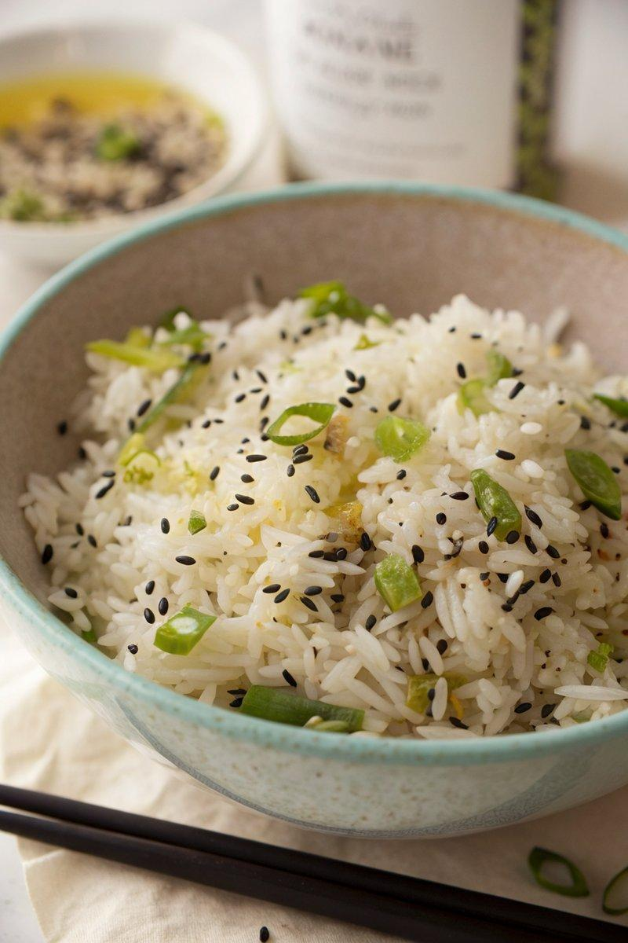

INGREDIENTS  - {'group': 'Main', 'item': '15ml garlic oil'}  - {'group': 'Main', 'item': '4 spring onions, finely sliced'}  - {'group': 'Main', 'item': '2 tsp nigella seeds or black mustard seeds'}  - {'group': 'Main', 'item': '300g Thai or basmati rice'}  - {'group': 'Main', 'item': '400ml coconut milk'}  - {'group': 'Main', 'item': '600ml freshly boiled water'}  - {'group': 'Seasoning', 'item': '1 tsp sea salt flakes'}  - {'group': 'Seasoning', 'item': 'Juice of 1 lime'} | PREP  Slice the spring onions finely. Measure out the garlic oil, nigella seeds, rice, coconut milk, and lime juice.  COOK  Warm the garlic oil in a heavy-based pan over medium heat. Add the sliced spring onions and nigella seeds, stirring for about 1 minute until fragrant. Stir in the rice, ensuring it is well coated with the oil and mixed with the seeds. Combine the coconut milk with freshly boiled water to make 1 litre of liquid, then add this to the rice along with the salt. Stir well, bring to a boil, then reduce the heat to low, cover, and simmer for 15 minutes until the rice is tender and the liquid is absorbed.  PLATING  Fluff the rice with a fork, drizzle with lime juice, and adjust seasoning with additional salt or lime juice if needed before serving.

NOTES:
This coconut rice pairs well with spicy curries or grilled meats. Adjust the lime juice to your taste preference.

