CALAMARI PASTA WITH GARLIC AND VERMOUTH  COOK TIME: 10 mins  SOURCE: Unknown  #seafood #Italian #sauté | 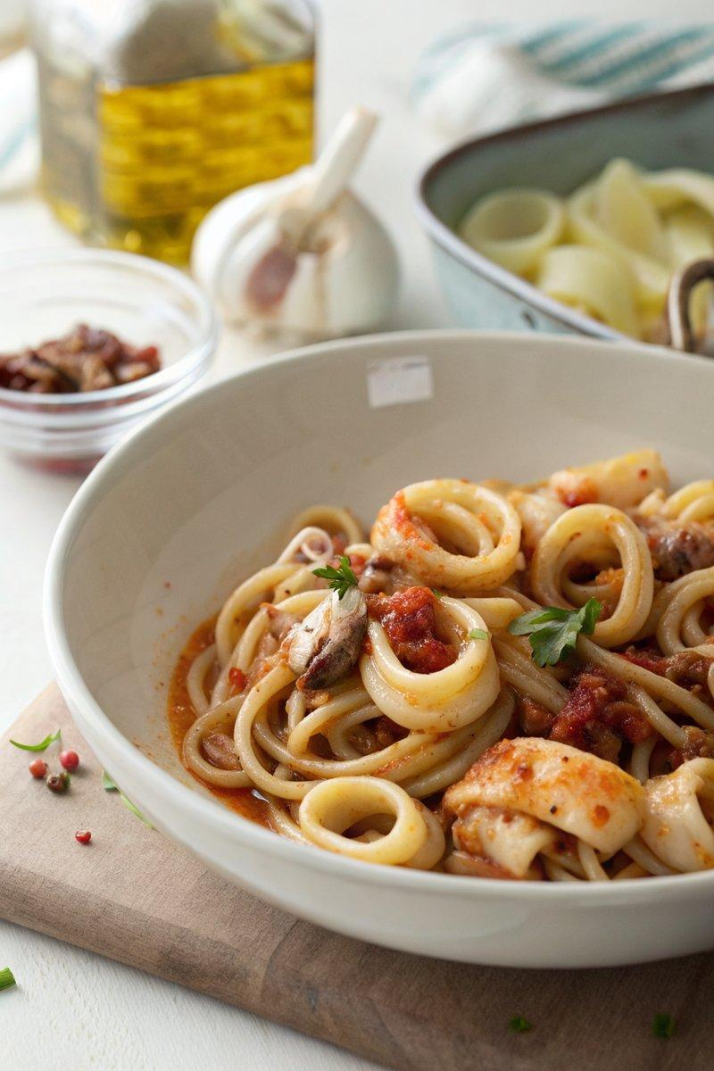

INGREDIENTS  - {'group': 'Main', 'item': '500g pasta, calamari-ring shape'}  - {'group': 'Main', 'item': '500g baby squid, cleaned and sliced'}  - {'group': 'Main', 'item': '2 tbsp olive oil'}  - {'group': 'Main', 'item': '4 spring onions, finely sliced'}  - {'group': 'Main', 'item': '1 clove garlic, peeled'}  - {'group': 'Main', 'item': '1 fresh chilli, de-seeded and diced'}  - {'group': 'Sauce', 'item': '125ml dry white vermouth or white wine'}  - {'group': 'Sauce', 'item': '60ml pasta cooking water'}  - {'group': 'Sauce', 'item': '1 tbsp unsalted butter'}  - {'group': 'Garnish', 'item': 'handful chopped parsley'} | PREP  Slice the squid into 1cm rings and leave the tentacles whole. Finely slice the spring onions, peel the garlic, and dice the chilli after removing the seeds.  COOK  Bring a large pot of salted water to a boil and cook the pasta according to package instructions. Meanwhile, heat olive oil in a pan over medium heat. Sauté the spring onions for 1 minute, then add grated garlic and diced chilli, stirring well. Add the squid rings and cook for about 2 minutes. Pour in the vermouth and simmer for another 2-3 minutes until the squid is tender and the liquid reduces. Stir in the reserved pasta water and butter, allowing the sauce to thicken slightly.  PLATING  Drain the pasta and combine it with the squid sauce in the pan. Toss everything together until well coated. Sprinkle with chopped parsley before serving.

NOTES:
For a richer flavour, substitute the vermouth with a dry white wine. Adjust the amount of chilli to your heat preference.

