CLAMS WITH CHORIZO AND SHERRY  COOK TIME: 5 mins  SOURCE: Unknown  #clams #spanish #pan-fry | 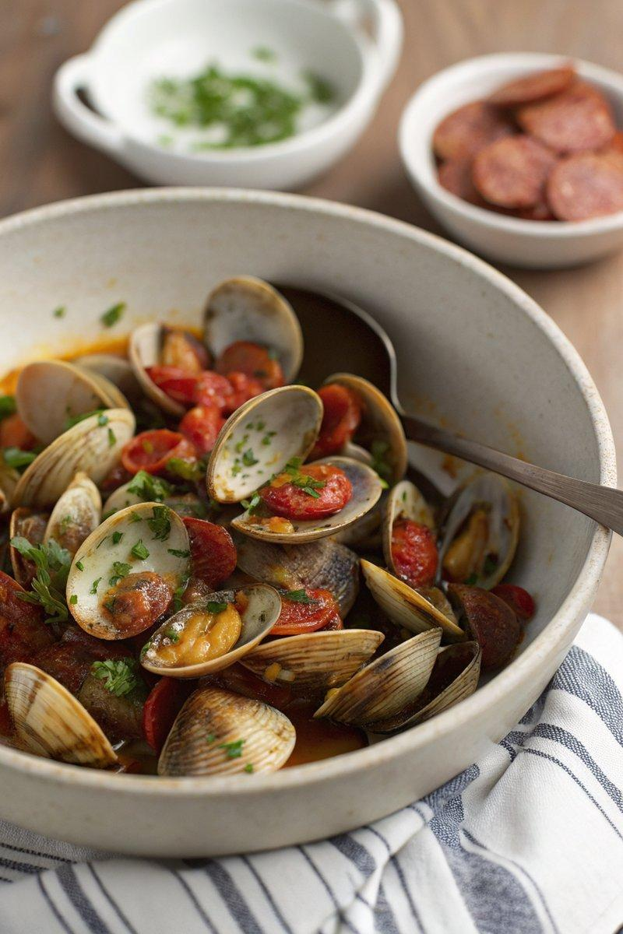

INGREDIENTS  - {'group': 'Main', 'item': '1kg clams'}  - {'group': 'Main', 'item': '500g chorizo sausage, sliced into thick coins'}  - {'group': 'Sauce', 'item': '125ml amontillado sherry'}  - {'group': 'Garnish', 'item': '3 tbsp snipped chives'} | PREP  Soak the clams in a large bowl of cold water to remove any sand. Slice the chorizo into thick coins and snip the chives.  COOK  In a large, dry wok or heavy-based pan, fry the chorizo slices over medium heat until they release their oil and become slightly crispy. Remove the chorizo and keep warm. Drain the clams, discarding any that remain open or have broken shells. Increase the heat to high, add the clams to the pan with the chorizo oil, pour in the sherry, and cover with a lid. Cook for 2-3 minutes until the clams open, discarding any that do not.  PLATING  Return the chorizo to the pan, sprinkle with chives, and stir gently. Serve immediately with steamed baby potatoes or crusty bread to soak up the juices.

NOTES:
Ensure all clams are closed before cooking and discard any that do not open after cooking.

