PAN-SEARED SALMON WITH SUSHI RICE AND ASIAN SAUCE  COOK TIME: 10 mins  SOURCE: Unknown  #salmon #asian #pan-fry | 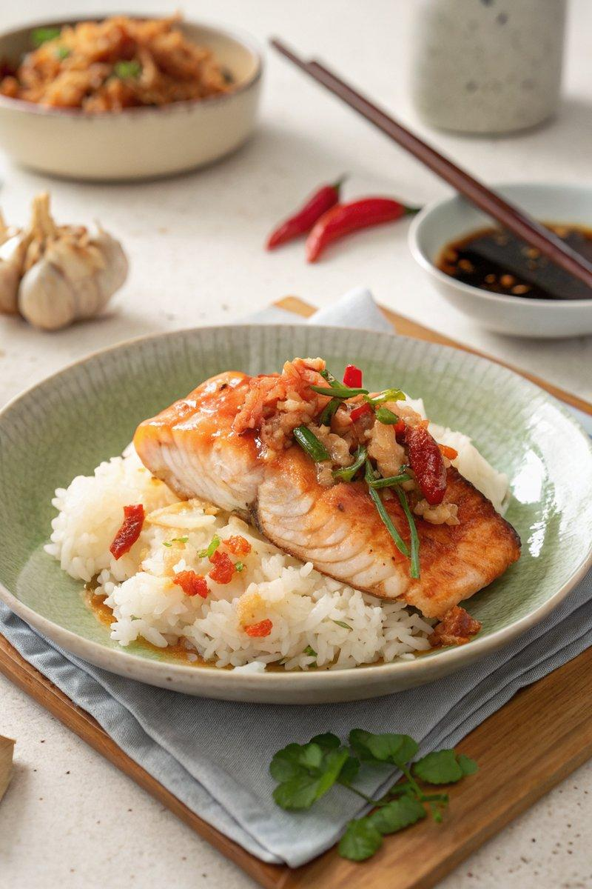

INGREDIENTS  - {'group': 'Main', 'item': '425g sushi rice'}  - {'group': 'Main', 'item': '500g skinless salmon fillet'}  - {'group': 'Sauce', 'item': '2 cloves garlic, minced'}  - {'group': 'Sauce', 'item': '2 Thai red chillies, finely chopped'}  - {'group': 'Sauce', 'item': '2 tbsp minced ginger'}  - {'group': 'Sauce', 'item': '4 tbsp fish sauce'}  - {'group': 'Sauce', 'item': '2 tbsp sake'}  - {'group': 'Sauce', 'item': '2 tbsp mirin'}  - {'group': 'Sauce', 'item': '2 tbsp lime juice'}  - {'group': 'Sauce', 'item': '2 tbsp water'} | PREP  Rinse the sushi rice under cold water until the water runs clear. Mince the garlic and ginger, and finely chop the Thai red chillies.  COOK  Cook the sushi rice according to the package instructions or in a rice cooker. Heat a frying pan over medium heat and sear the salmon for 4-5 mins on one side, then flip and cook for 1 min on the other side until just opaque. Remove and wrap in foil to keep warm.  PLATING  Place the cooked sushi rice in bowls. Unwrap the salmon and flake it over the rice. Serve with the sauce on the side, allowing diners to drizzle it over their dish.

NOTES:
The sauce can be prepared a day in advance and stored in the fridge. Shake well before serving.

