COCONUT AND CHERRY BANANA BREAD  COOK TIME: 50 mins  SOURCE: Unknown  #banana #American #bake | 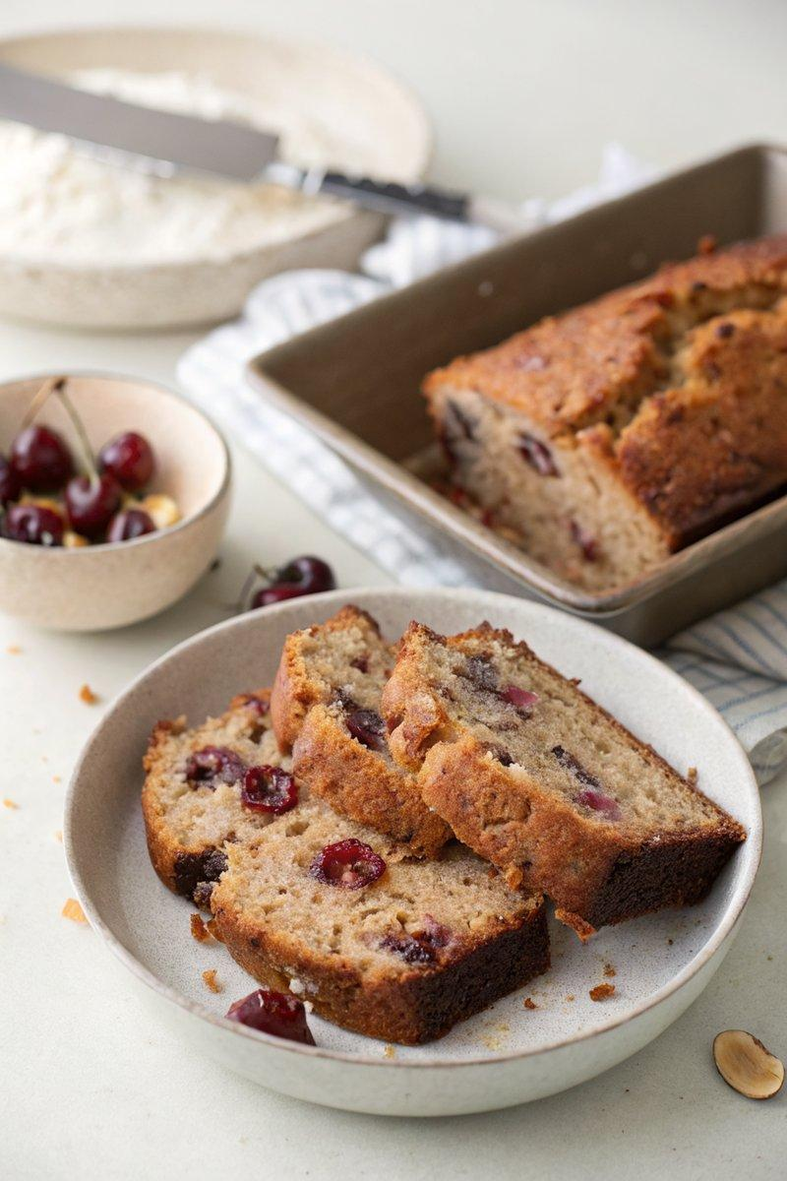

INGREDIENTS  - {'group': 'Main', 'item': '125g unsalted butter, plus extra for greasing'}  - {'group': 'Main', 'item': '4 small-medium bananas (~500g with skin)'}  - {'group': 'Main', 'item': '150g caster sugar'}  - {'group': 'Main', 'item': '2 eggs'}  - {'group': 'Main', 'item': '175g plain flour'}  - {'group': 'Main', 'item': '2 tsp baking powder'}  - {'group': 'Main', 'item': '1 tsp bicarbonate of soda'}  - {'group': 'Main', 'item': '100g dried cherries'}  - {'group': 'Main', 'item': '100g desiccated coconut'} | PREP  Preheat the oven to 170°C (340°F (171°C)). Grease a 900g loaf tin with butter or line it with baking parchment. Peel and mash the bananas in a bowl.  COOK  Melt the butter in a saucepan and let it cool slightly. In a large bowl, beat the sugar into the melted butter, then mix in the mashed bananas and eggs until smooth. Fold in the flour, baking powder, and bicarbonate of soda until just combined. Stir in the dried cherries and desiccated coconut. Pour the batter into the prepared loaf tin and smooth the top.  PLATING  Bake for about 50 minutes, checking after 45 minutes. The bread is done when it starts to pull away from the sides of the tin and feels firm to the touch. Let it cool in the tin for 10 minutes before transferring to a wire rack to cool completely.

NOTES:
This bread can be stored in an airtight container for up to 3-4 days. It can also be frozen, tightly wrapped in cling film and foil, for up to 3 months.

