CHOCOLATE BANANA MUFFINS  COOK TIME: 15-20 mins  SOURCE: Unknown  #banana #chocolate #bake | 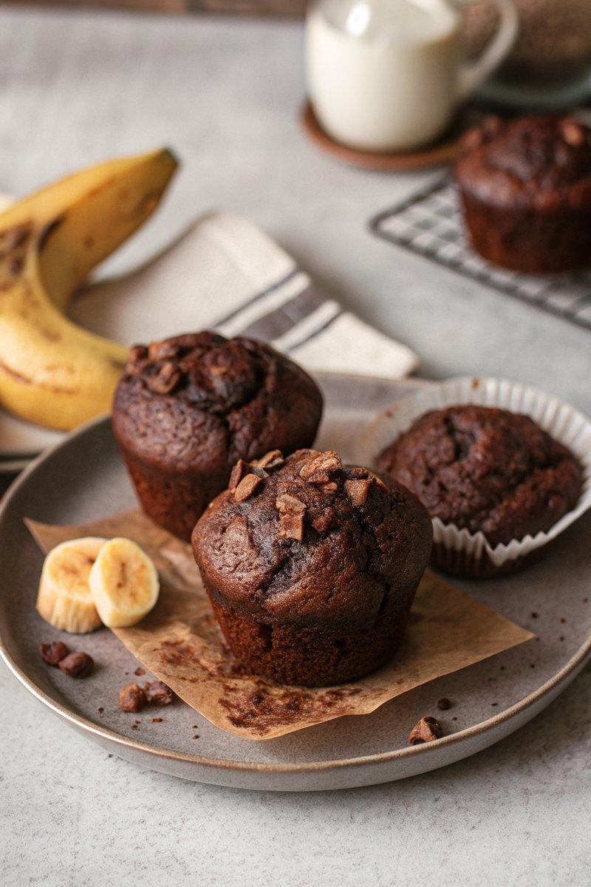

INGREDIENTS  - {'group': 'Main', 'item': '3 very ripe bananas'}  - {'group': 'Main', 'item': '125 ml vegetable oil'}  - {'group': 'Main', 'item': '2 eggs'}  - {'group': 'Main', 'item': '100g soft light brown sugar'}  - {'group': 'Main', 'item': '225g plain flour'}  - {'group': 'Main', 'item': '45 ml cocoa powder, sifted'}  - {'group': 'Main', 'item': '1 tsp bicarbonate of soda'} | PREP  Preheat the oven to 200°C (400°F (200°C)). Line a 12-bun muffin tin with paper cases. Mash the bananas in a bowl until smooth.  COOK  Incorporate the vegetable oil into the mashed bananas, followed by the eggs and brown sugar, mixing well. In a separate bowl, combine the plain flour, cocoa powder, and bicarbonate of soda. Gradually fold the dry ingredients into the banana mixture until just combined. Divide the batter evenly among the muffin cases.  PLATING  Bake the muffins in the preheated oven for 15-20 minutes, until they are dark and risen. Allow them to cool slightly in the tin before transferring to a wire rack to cool completely.

NOTES:
Store muffins in an airtight container for up to 3 days. They can also be frozen for up to 2 months; defrost at room temperature and reheat if desired.

