CINNAMON PLUM COMPOTE WITH FRENCH TOAST  COOK TIME: 20 mins  SOURCE: Unknown  #plum #French #pan-fry | 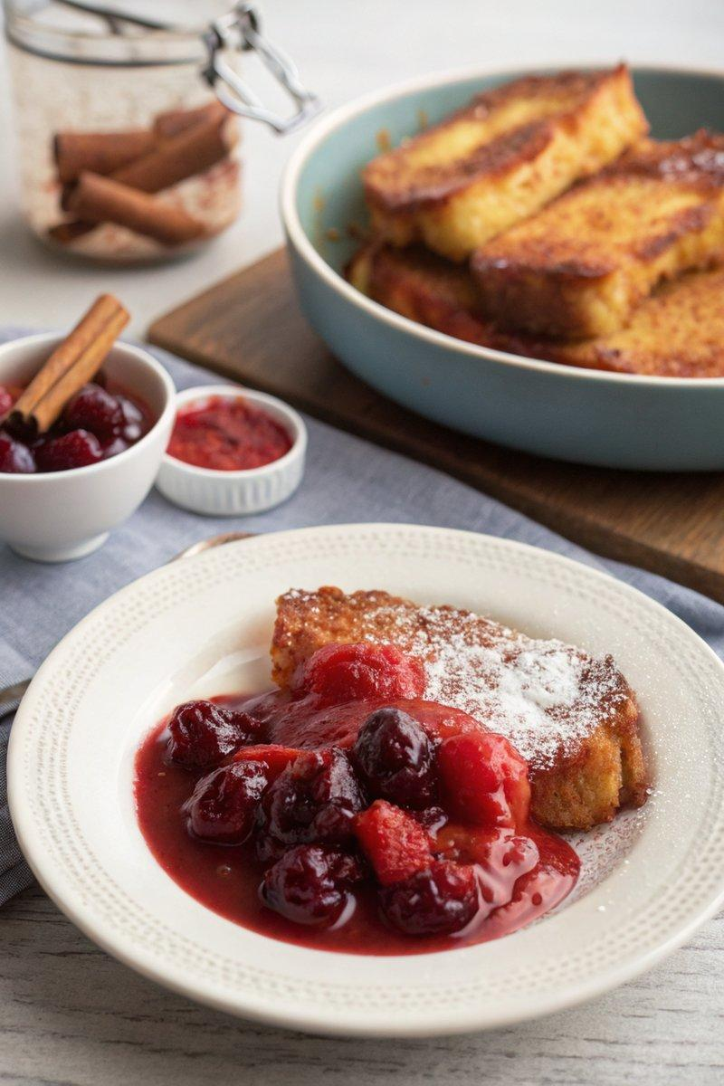

INGREDIENTS  - {'group': 'Plum Compote', 'item': '1 cinnamon stick'}  - {'group': 'Plum Compote', 'item': '250 ml cranberry juice'}  - {'group': 'Plum Compote', 'item': '100g caster sugar'}  - {'group': 'Plum Compote', 'item': '500g plums, halved and pitted'}  - {'group': 'French Toast', 'item': '2 eggs'}  - {'group': 'French Toast', 'item': '60 ml full-fat milk'}  - {'group': 'French Toast', 'item': '1 tsp ground cinnamon'}  - {'group': 'French Toast', 'item': '4 slices stale white bread'}  - {'group': 'French Toast', 'item': '30g salted butter'} | PREP  Halve and pit the plums. In a bowl, whisk together the eggs, milk, and ground cinnamon. Slice the bread if necessary.  COOK  In a saucepan, combine cranberry juice and caster sugar over low heat until the sugar dissolves. Add the cinnamon stick and bring to a boil. Add the plums and simmer for about 10 mins until tender. Meanwhile, soak two slices of bread in the egg mixture. Melt half the butter in a frying pan over medium heat and cook the soaked bread for 2 mins on each side until golden. Repeat with remaining bread and butter.  PLATING  Serve the French toast warm, topped with the cinnamon plum compote.

NOTES:
The plum compote can be made ahead and stored in an airtight container in the fridge for up to a week. Reheat gently before serving.

