CHOCOLATE CHIP BREAD PUDDING  COOK TIME: 40-50 mins  SOURCE: Unknown  #bread #American #baked | 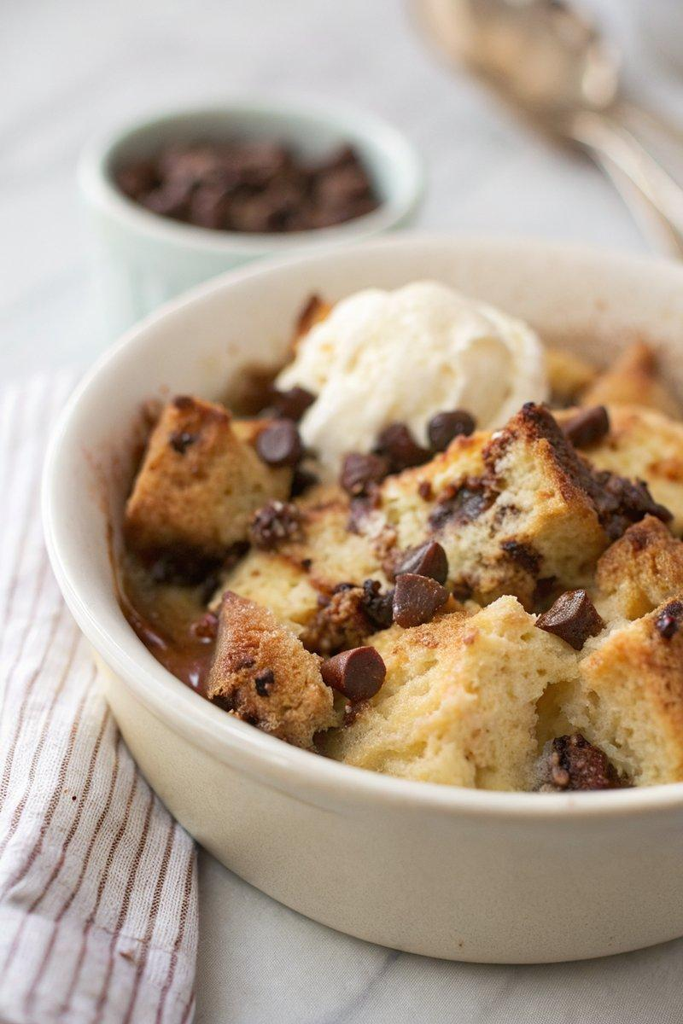

INGREDIENTS  - {'group': 'Main', 'item': '250g stale bread, cut into 3cm cubes'}  - {'group': 'Main', 'item': '100g chocolate chips'}  - {'group': 'Custard', 'item': '3 eggs'}  - {'group': 'Custard', 'item': '40g soft light brown sugar'}  - {'group': 'Custard', 'item': '30ml dark rum'}  - {'group': 'Custard', 'item': '120ml double cream'}  - {'group': 'Custard', 'item': '500ml full-fat milk'}  - {'group': 'Topping', 'item': '4 tsp demerara sugar'} | PREP  Preheat the oven to 170°C (340°F (171°C)). Grease a 23cm (9-inch) diameter ovenproof dish with butter. If the bread isn't stale, leave slices to dry on a rack before cubing.  COOK  Place the bread cubes in the prepared dish and scatter chocolate chips evenly among them. In a bowl, whisk together the eggs, brown sugar, rum, double cream, and milk. Pour this mixture over the bread, pressing down to ensure the bread is well-coated. Allow the mixture to soak for 20 minutes. Sprinkle the top with demerara sugar.  PLATING  Bake in the oven for 40-50 minutes until the top is golden and the custard is set. Let it stand for a few minutes before serving.

NOTES:
If your oven browns unevenly, rotate the dish halfway through baking. The pudding is best served warm.

