PEAR AND APPLE PANDOWDY  COOK TIME: 25 mins  SOURCE: Unknown  #pear #apple #baked | 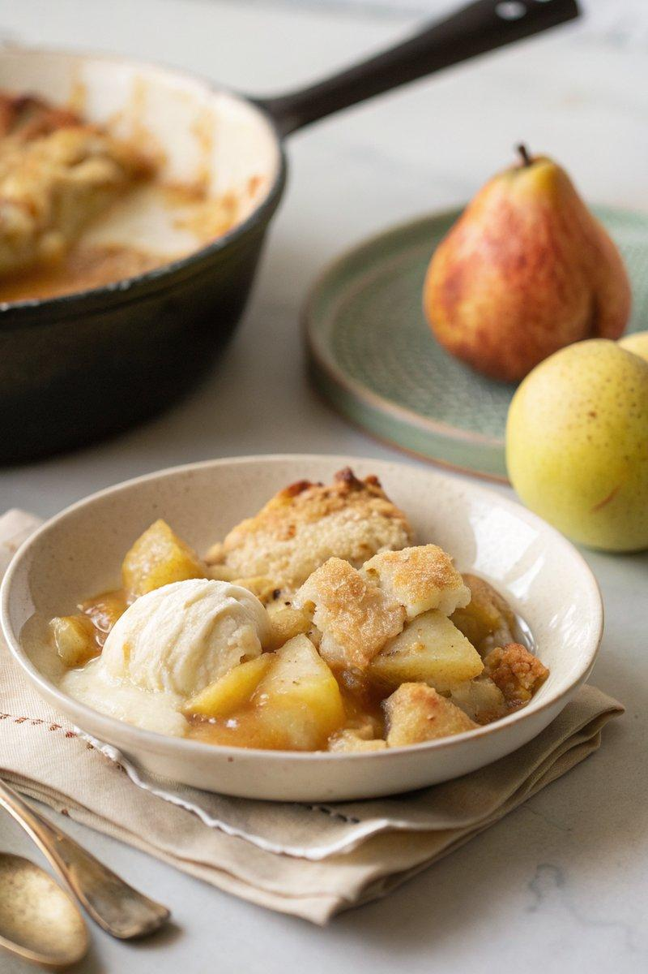

INGREDIENTS  - {'group': 'Main', 'item': '4 Williams pears, peeled, cored, and cut into 2cm pieces'}  - {'group': 'Main', 'item': '2 Golden Delicious apples, peeled, cored, and cut into 1cm pieces'}  - {'group': 'Main', 'item': '50g soft unsalted butter'}  - {'group': 'Main', 'item': '50g caster sugar'}  - {'group': 'Main', 'item': 'Finely grated zest of 1 lemon'}  - {'group': 'Pastry', 'item': '225g plain flour'}  - {'group': 'Pastry', 'item': 'Pinch of salt'}  - {'group': 'Pastry', 'item': '75g very cold butter, cut into 1cm cubes'}  - {'group': 'Pastry', 'item': '35g cold vegetable shortening'}  - {'group': 'Pastry', 'item': '125ml cold full-fat milk'}  - {'group': 'Garnish', 'item': '1/2 tsp caster sugar for sprinkling'}  - {'group': 'For Serving', 'item': 'Double cream (optional)'} | PREP  Peel, core, and chop the pears into 2cm pieces and the apples into 1cm pieces. Grate the lemon zest. Prepare the pastry by combining flour and salt in a mixer, adding cold butter and shortening, and mixing until crumbly. Gradually add milk until the dough binds, then form into a ball and chill if necessary.  COOK  Preheat the oven to 200°C (400°F (200°C)). In a cast-iron skillet, melt 50g butter over medium heat. Add the pears, apples, sugar, and lemon zest, cooking gently for 10 mins until the fruit begins to caramelize. Roll out the pastry to the size of the skillet, place over the fruit, and tuck in the edges. Make three slashes in the pastry, sprinkle with sugar, and bake for 25 mins until golden.  PLATING  Carefully remove the skillet from the oven, remembering the handle will be hot. Serve the pandowdy warm, optionally with a side of double cream.

NOTES:
The pandowdy can be assembled up to 2 days in advance, but ensure the fruit is fully cooled before adding the pastry. If frozen, thaw overnight and bake with an additional 10 minutes of cooking time.

