SOUTH INDIAN VEGETABLE CURRY  COOK TIME: 15 mins  SOURCE: Unknown  #vegetarian #Indian #sauté | 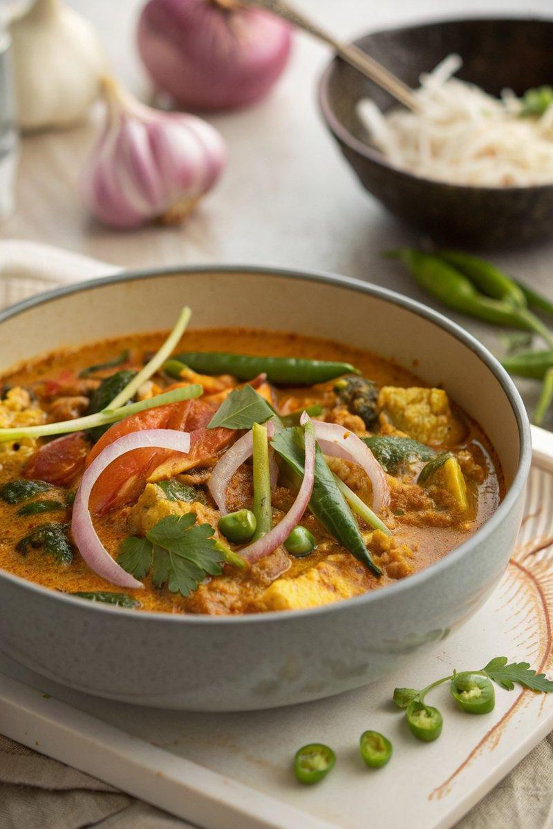

INGREDIENTS  - {'group': 'Main', 'item': '2 tbsp garlic oil'}  - {'group': 'Main', 'item': '1 onion, peeled, halved and sliced into half-moons'}  - {'group': 'Main', 'item': '1 green chilli, de-seeded and finely chopped'}  - {'group': 'Main', 'item': '2 cm fresh ginger, peeled and cut into fine strips'}  - {'group': 'Seasoning', 'item': 'pinch of sea salt flakes'}  - {'group': 'Seasoning', 'item': '1 tsp crushed chilli flakes'}  - {'group': 'Seasoning', 'item': '1 tsp turmeric'}  - {'group': 'Seasoning', 'item': '1 tsp ground cumin'}  - {'group': 'Seasoning', 'item': '1 tsp ground coriander'}  - {'group': 'Seasoning', 'item': '1 tsp ground ginger'}  - {'group': 'Sauce', 'item': '400 ml coconut milk'}  - {'group': 'Sauce', 'item': '600 ml vegetable stock'}  - {'group': 'Sauce', 'item': '1 tsp sugar'}  - {'group': 'Sauce', 'item': '1 tbsp tamarind paste'}  - {'group': 'Main', 'item': '350 g cauliflower, broken into florets'}  - {'group': 'Main', 'item': '350 g broccoli, broken into florets'}  - {'group': 'Main', 'item': '100 g fine beans, trimmed and halved'}  - {'group': 'Main', 'item': '125 g baby corn, halved'}  - {'group': 'Main', 'item': '150 g sugar snap peas'}  - {'group': 'Garnish', 'item': '2 tbsp chopped dill or coriander'} | PREP  Peel and slice the onion into half-moons. De-seed and finely chop the green chilli. Peel and cut the ginger into fine strips. Break the cauliflower and broccoli into florets. Trim and halve the fine beans and baby corn.  COOK  Heat the garlic oil in a large saucepan over medium heat. Add the onion and a pinch of salt, sauté until softened. Stir in the green chilli and ginger, cooking for 1 minute. Add the crushed chilli flakes, turmeric, cumin, coriander, and ground ginger, stirring well. Pour in the coconut milk, vegetable stock, sugar, and tamarind paste, mixing to combine. Bring to a boil, then add the cauliflower and broccoli. Cook for 10 minutes, then add the fine beans and baby corn. Continue cooking for 5 minutes, checking for tenderness. Finally, add the sugar snap peas and cook until heated through.  PLATING  Serve the curry hot, generously sprinkled with chopped dill or coriander. Accompany with plain rice or warmed Indian flatbread.

NOTES:
This curry is versatile and can be adjusted based on available vegetables. Ensure all vegetables are cooked to your desired tenderness before serving.

