LEMON MERINGUE FOOL  COOK TIME: 0 mins  SOURCE: Unknown  #lemon #British #no-cook | 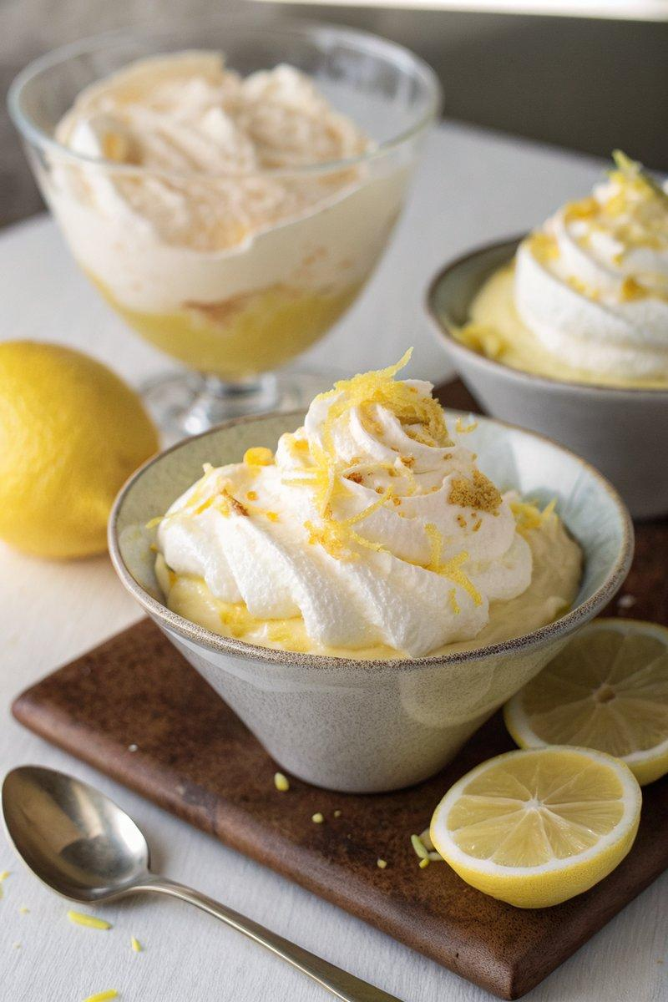

INGREDIENTS  - {'group': 'Main', 'item': '150g lemon curd'}  - {'group': 'Main', 'item': '1-2 tsp limoncello or lemon juice'}  - {'group': 'Main', 'item': '250ml double cream'}  - {'group': 'Main', 'item': '1 meringue nest'}  - {'group': 'Garnish', 'item': 'lemon zest'} | PREP  In a bowl, combine the lemon curd with limoncello or lemon juice, adjusting the amount to achieve a smooth consistency.  COOK  In a separate bowl, whisk the double cream until it holds its shape but is not overly stiff. Gently fold half of the lemon curd mixture into the whipped cream, followed by the remaining half, creating a marbled effect. Crumble the meringue nest into the mixture and fold gently to combine.  PLATING  Spoon the mixture into four small martini glasses or two larger goblets. Garnish with lemon zest and a drizzle of lemon curd. Serve immediately or refrigerate for up to 3 hours before serving.

NOTES:
The dessert can be prepared a few hours in advance and kept chilled. If freezing, note that the meringue will soften.

