ORANGE AND BLACKBERRY TRIFLE  COOK TIME: No cooking required  SOURCE: Unknown  #fruit #British #no-cook | 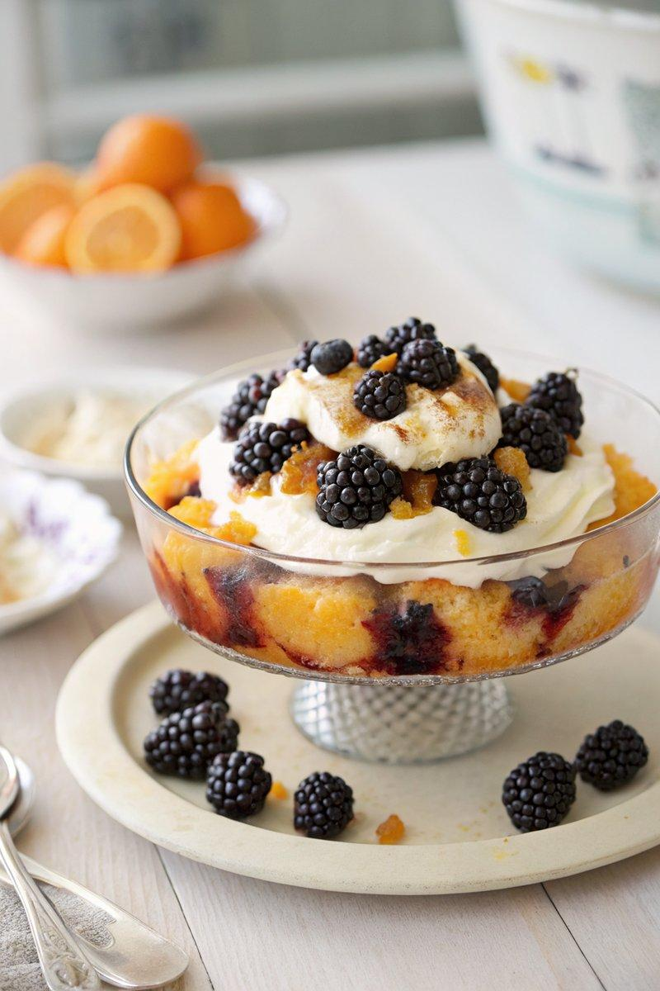

INGREDIENTS  - {'group': 'Main', 'item': '350g marmalade pudding cake'}  - {'group': 'Main', 'item': '80ml Cointreau or other orange liqueur'}  - {'group': 'Main', 'item': 'Zest and juice of 1 orange or 2 clementines (~100ml)'}  - {'group': 'Main', 'item': '250ml double cream'}  - {'group': 'Main', 'item': '300g blackberries'} | PREP  Slice the marmalade pudding cake and arrange the slices on a plate or shallow dish. Zest the orange or clementines and set the zest aside. Squeeze the juice from the orange or clementines.  COOK  Drizzle the cake slices with Cointreau, then pour the orange juice over them, ensuring they are well-soaked. Whip the double cream until it is thick but still soft.  PLATING  Spoon the whipped cream over the soaked cake slices. Arrange the blackberries on top of the cream, then scatter the reserved zest over the trifle before serving.

NOTES:
The base can be prepared a couple of hours in advance, but add the cream and fruit just before serving for the best texture.

