NO-CHURN PIÑA COLADA ICE CREAM  COOK TIME: 5 mins  SOURCE: Unknown  #dessert #American #no-cook | 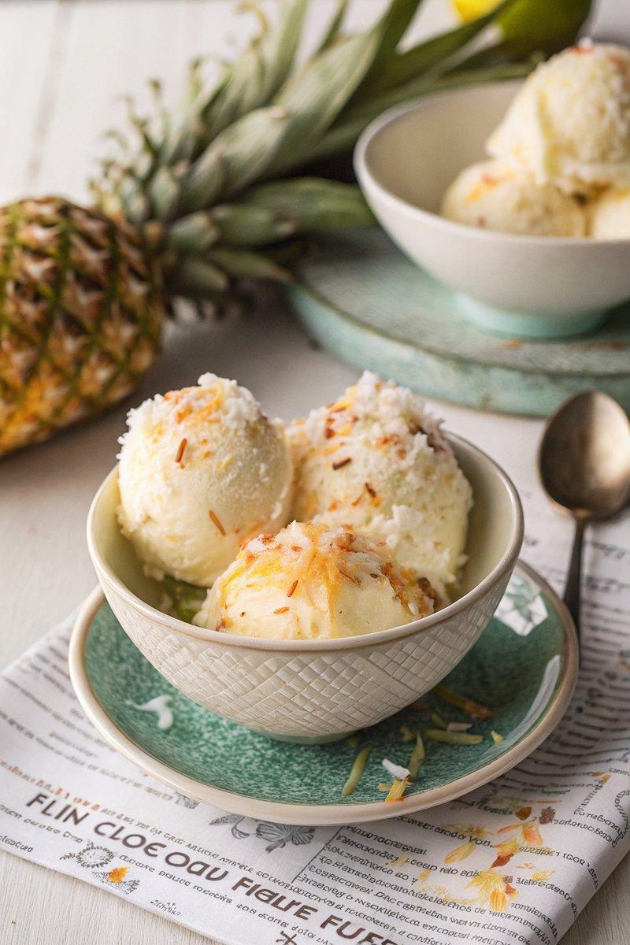

INGREDIENTS  - {'group': 'Main', 'item': '125ml pineapple juice'}  - {'group': 'Main', 'item': '50ml Malibu (white coconut rum)'}  - {'group': 'Main', 'item': 'few drops coconut flavouring'}  - {'group': 'Main', 'item': '2 tsp lime juice'}  - {'group': 'Main', 'item': '100g icing sugar'}  - {'group': 'Main', 'item': '500ml double cream'}  - {'group': 'Garnish', 'item': '75g sweetened shredded coconut'} | PREP  In a large bowl, combine the pineapple juice, Malibu, coconut flavouring, and lime juice. Add the icing sugar and whisk until dissolved.  COOK  Continue whisking the mixture while gradually adding the double cream. Whisk until soft peaks form. Taste and adjust with more coconut flavouring or lime juice if needed. Transfer the mixture into an airtight container, smooth the top, and freeze until solid.  PLATING  Before serving, toast the sweetened shredded coconut in a hot, dry pan until golden. Sprinkle over each serving of ice cream.

NOTES:
The ice cream is best consumed within a week to avoid iciness. For a fun presentation, serve in hollowed-out coconut shells.

