SAKE AND WASABI PRAWNS  COOK TIME: 5 mins  SOURCE: Unknown  #prawns #asian #stir-fry | 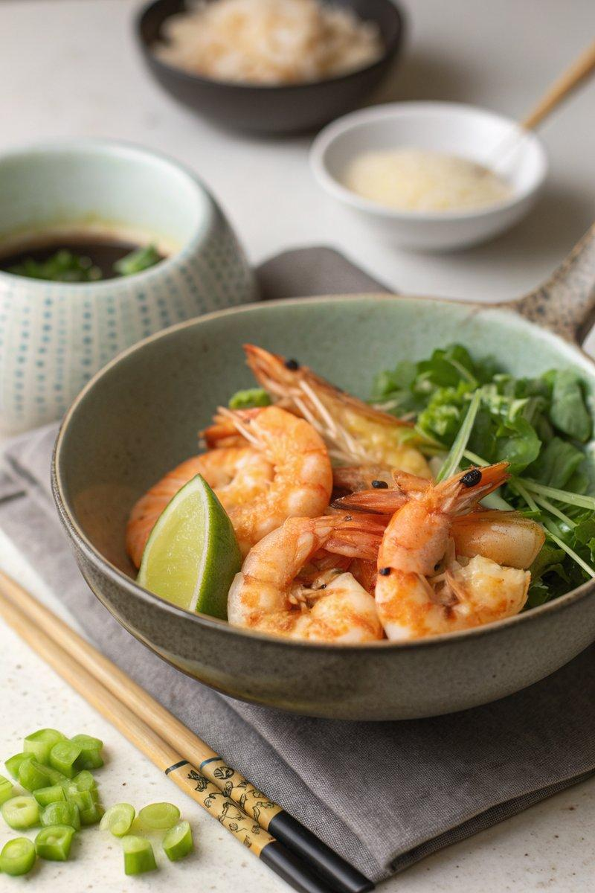

INGREDIENTS  - {'group': 'Main', 'item': '200g frozen raw king prawns'}  - {'group': 'Sauce', 'item': '30ml water'}  - {'group': 'Sauce', 'item': '30ml sake'}  - {'group': 'Sauce', 'item': '1/2 tsp sea salt flakes'}  - {'group': 'Sauce', 'item': '15ml lime juice'}  - {'group': 'Sauce', 'item': '1/2 tsp wasabi powder'}  - {'group': 'Cooking', 'item': '2 tsp garlic oil'}  - {'group': 'Cooking', 'item': '2 spring onions, finely sliced'}  - {'group': 'For Serving', 'item': 'salad leaves, rice or noodles'}  - {'group': 'Garnish', 'item': '2-3 tbsp chopped fresh coriander (optional)'} | PREP  In a small bowl, combine the water, sake, sea salt, lime juice, and wasabi powder. Set aside. Finely slice the spring onions.  COOK  Heat a wok over medium-high heat and add the garlic oil. Stir-fry the spring onions for about 1 minute. Add the frozen prawns and cook for approximately 3 minutes, until they begin to turn pink. Pour in the prepared sauce mixture, bring to a simmer, and cook for an additional 2 minutes, stirring occasionally, until the prawns are fully cooked.  PLATING  Serve the prawns over a bed of salad leaves, rice, or noodles. Garnish with chopped fresh coriander if desired.

NOTES:
For a quick meal, use pre-chopped ginger and chilli from a jar. Adjust the amount of wasabi to taste if you prefer a milder or spicier dish.

