SAFFRON SEAFOOD STEW  COOK TIME: 10 mins  SOURCE: Unknown  #seafood #Mediterranean #simmer | 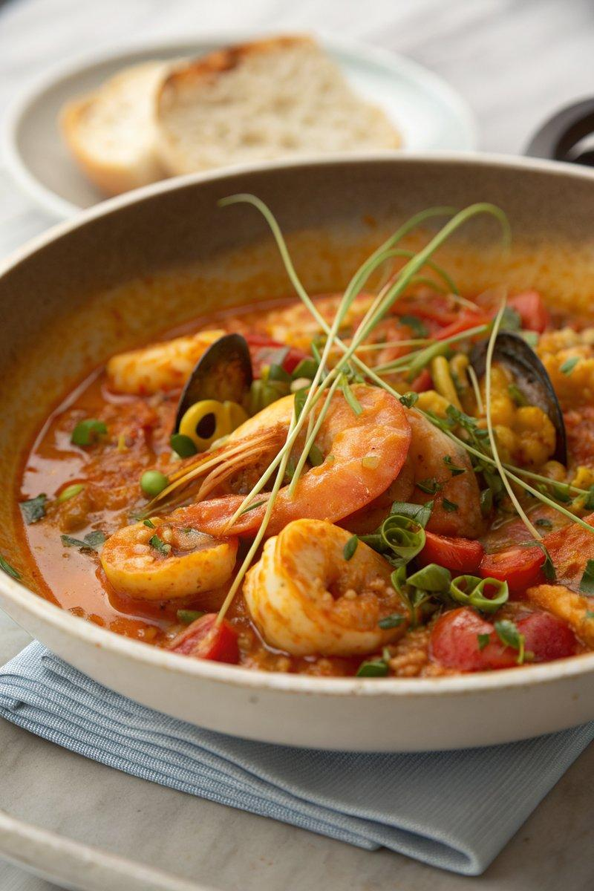

INGREDIENTS  - {'group': 'Main', 'item': '400g frozen mixed seafood'}  - {'group': 'Main', 'item': '6 spring onions, finely sliced'}  - {'group': 'Main', 'item': '1 x 227g can chopped tomatoes'}  - {'group': 'Sauce', 'item': 'pinch saffron threads'}  - {'group': 'Sauce', 'item': '250ml freshly boiled water'}  - {'group': 'Sauce', 'item': '125ml dry vermouth or dry white wine'}  - {'group': 'Seasoning', 'item': '4 tsp garlic oil'}  - {'group': 'Seasoning', 'item': '½ tsp dried tarragon'}  - {'group': 'Seasoning', 'item': '1 tsp sea salt flakes'}  - {'group': 'Seasoning', 'item': 'pepper, to taste'}  - {'group': 'Garnish', 'item': 'fresh herbs, optional'} | PREP  Dissolve the saffron threads in 250ml of freshly boiled water. Finely slice the spring onions and set aside.  COOK  Heat the garlic oil in a wide, shallow pan over medium heat. Sauté the spring onions and dried tarragon for about a minute. Pour in the vermouth and let it bubble for another minute. Add the saffron water and chopped tomatoes, bringing the mixture to a boil. Stir in half of the salt. Increase the heat to high, add the frozen seafood, and return to a boil. Reduce the heat to medium and simmer for 3-4 minutes until the seafood is cooked through.  PLATING  Season the stew with pepper and additional salt if needed. Garnish with fresh herbs if desired. Serve hot with crusty bread for dipping.

NOTES:
For a heartier meal, serve the stew over pasta. Adjust seasoning to taste with additional salt and pepper.

