PASTA WITH PANCETTA, PARSLEY, AND PEPPERS  COOK TIME: 15 mins  SOURCE: Unknown  #pasta #Italian #pan-fry | 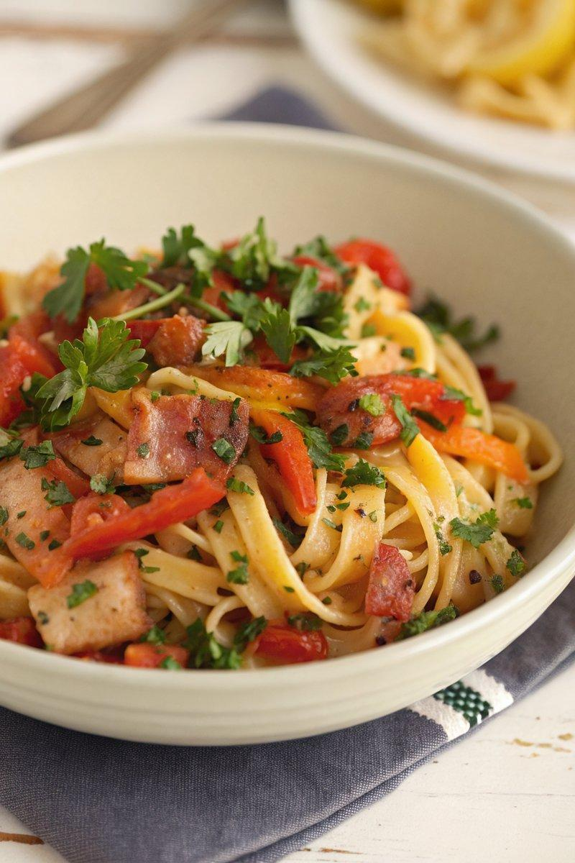

INGREDIENTS  - {'group': 'Main', 'item': '250g spaghetti'}  - {'group': 'Main', 'item': '140g pancetta cubes or 200g smoked lardons'}  - {'group': 'Main', 'item': '190g chargrilled or flame-roasted peppers, drained'}  - {'group': 'Seasoning', 'item': '1 tsp garlic oil'}  - {'group': 'Seasoning', 'item': '1 tsp dried chilli flakes'}  - {'group': 'Seasoning', 'item': 'Zest and juice of 1 lemon'}  - {'group': 'Seasoning', 'item': 'Salt and pepper, to taste'}  - {'group': 'Garnish', 'item': '20g parsley, chopped'} | PREP  Chop the parsley and zest the lemon. Drain and cut the chargrilled peppers into bite-sized pieces.  COOK  Boil a large pot of salted water and cook the spaghetti according to package instructions. Meanwhile, heat the garlic oil in a medium pan over medium heat. Add the pancetta and cook until crisp. Stir in the chilli flakes, lemon zest, and juice, then add 30ml of water. Let it bubble for a minute before adding the peppers and half of the parsley.  PLATING  Drain the spaghetti, reserving a small cup of pasta water. Toss the spaghetti with the pancetta mixture, adding reserved pasta water as needed to coat. Season with salt and pepper, and garnish with the remaining parsley before serving.

NOTES:
For a tangy twist, add a few capers to the sauce. Adjust the chilli flakes to your heat preference.

