SEAFOOD AND PORK PAELLA  COOK TIME: 20 mins  SOURCE: Unknown  #seafood #Spanish #simmer | 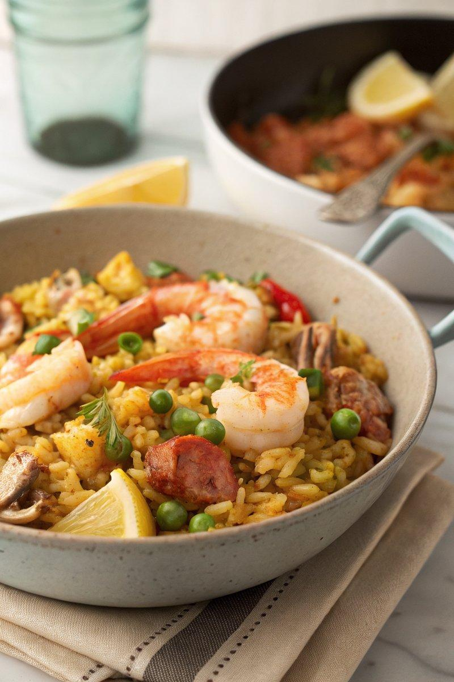

INGREDIENTS  - {'group': 'Main', 'item': '250g Bomba or arborio rice'}  - {'group': 'Main', 'item': '250g raw frozen prawns, thawed'}  - {'group': 'Main', 'item': '100g frozen baby squid, thawed and sliced'}  - {'group': 'Main', 'item': '250g cold cooked pork, chopped'}  - {'group': 'Main', 'item': '150g frozen peas'}  - {'group': 'Sauce', 'item': 'pinch saffron threads'}  - {'group': 'Sauce', 'item': '60ml oloroso sherry'}  - {'group': 'Sauce', 'item': '500ml chicken stock'}  - {'group': 'Seasoning', 'item': 'salt, to taste'}  - {'group': 'Garnish', 'item': '1 lemon, cut into wedges'}  - {'group': 'Garnish', 'item': 'small bunch fresh coriander, chopped'}  - {'group': 'Main', 'item': '2 tbsp olive oil'}  - {'group': 'Main', 'item': '3 spring onions, finely sliced'}  - {'group': 'Main', 'item': '1 clove garlic, finely sliced'} | PREP  Thaw the prawns and squid. Slice the spring onions and garlic. Chop the cooked pork into chunks. Prepare the chicken stock if using concentrate or cube.  COOK  Warm the saffron threads with sherry in a small pan over medium heat without boiling, then set aside. Heat olive oil in a wide pan over medium heat, sauté spring onions for a few minutes, then add garlic and cook for another minute. Stir in the rice to coat with oil, then add prawns, squid, pork, and peas, mixing well. Pour in the hot chicken stock and the saffron-sherry mixture. Stir and bring to a simmer, then reduce heat to low and cook uncovered for 15-20 mins until the rice absorbs the liquid and is tender.  PLATING  Fluff the rice with a fork, adjust seasoning with salt if needed. Serve the paella garnished with lemon wedges and chopped coriander.

NOTES:
Ensure the seafood is thoroughly thawed before cooking. Adjust the salt based on the saltiness of the stock used.

