MIXED MEAT PILAF  COOK TIME: 25 mins  SOURCE: Unknown  #meat #Middle Eastern #simmer | 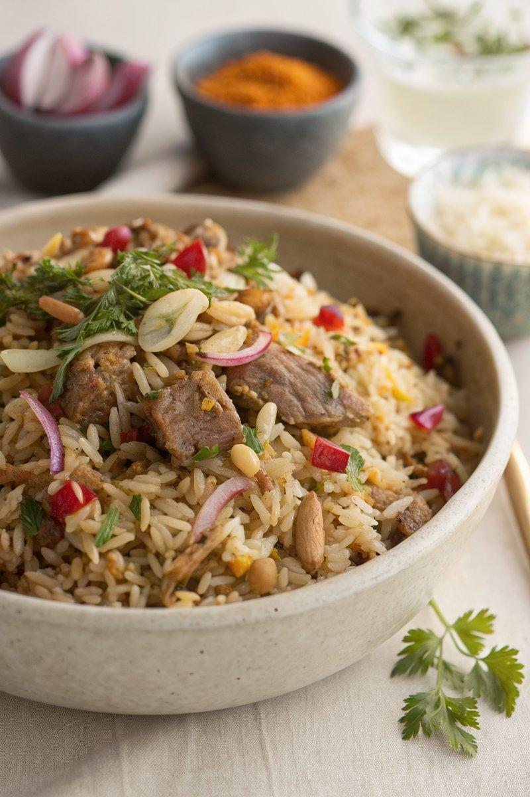

INGREDIENTS  - {'group': 'Main', 'item': '1 tbsp vegetable oil'}  - {'group': 'Main', 'item': '1 onion, finely chopped'}  - {'group': 'Main', 'item': '1/2 tsp cumin seeds'}  - {'group': 'Main', 'item': '1/2 tsp coriander seeds'}  - {'group': 'Main', 'item': '1/2 tsp dried thyme'}  - {'group': 'Main', 'item': '225g basmati rice'}  - {'group': 'Main', 'item': '500ml chicken stock'}  - {'group': 'Main', 'item': '150g shredded cold meat'}  - {'group': 'Seasoning', 'item': 'Salt and pepper, to taste'}  - {'group': 'Garnish', 'item': '2-3 tbsp toasted pine nuts or flaked almonds'}  - {'group': 'Garnish', 'item': '2 tbsp chopped fresh parsley (optional)'}  - {'group': 'Garnish', 'item': '2 tbsp chopped fresh coriander (optional)'}  - {'group': 'Garnish', 'item': '2-3 tbsp pomegranate seeds (optional)'} | PREP  Finely chop the onion and measure out the spices and rice. Prepare the chicken stock if using concentrate or cubes.  COOK  Heat the vegetable oil in a heavy-based saucepan over medium heat. Add the chopped onion and sauté for about 5 minutes until softened. Stir in the cumin seeds, coriander seeds, and dried thyme, cooking for another 5 minutes until the onion is fully softened and fragrant. Add the basmati rice, stirring to coat it in the spiced onion mixture until glossy. Pour in the hot chicken stock, bring to a boil, then reduce the heat to the lowest setting. Cover and simmer for 15 minutes. Stir in the shredded meat, cover again, and cook for an additional 5 minutes until the meat is heated through and the rice is tender.  PLATING  Fluff the pilaf with a fork and mix in most of the pine nuts, parsley, coriander, and pomegranate seeds. Serve in bowls, garnished with the remaining nuts and herbs.

NOTES:
This dish is versatile and can be made with any leftover meats you have on hand. Adjust the cooking time if using a rice blend.

