SALAMI AND BEAN PASTA  COOK TIME: 15 mins  SOURCE: Unknown  #pasta #Italian #sauté | 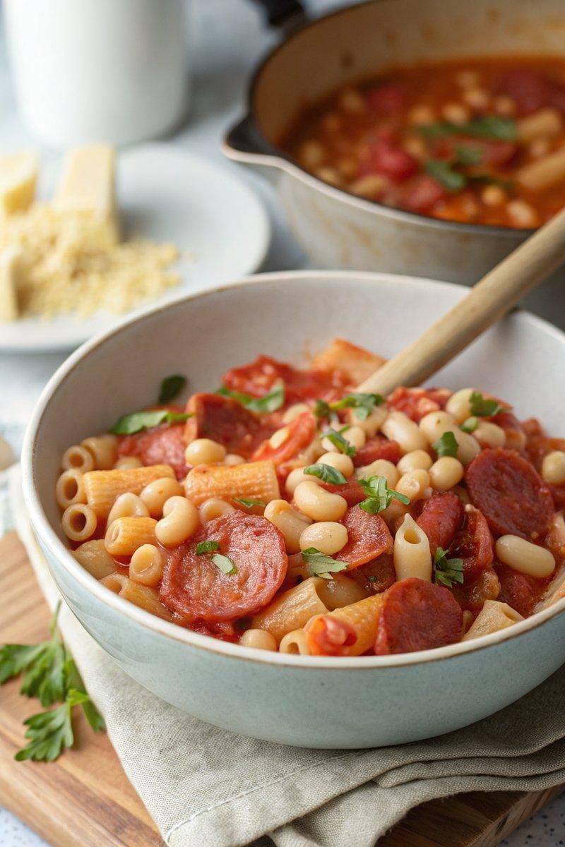

INGREDIENTS  - {'group': 'Main', 'item': '300g ditalini or mezzi tubetti pasta'}  - {'group': 'Main', 'item': '75g Milano salami, sliced into strips'}  - {'group': 'Main', 'item': '1 x 400g can chopped tomatoes'}  - {'group': 'Main', 'item': '30g butter, divided'}  - {'group': 'Main', 'item': '1 bouquet garni'}  - {'group': 'Main', 'item': '1 x 400g can cannellini beans, drained and rinsed'} | PREP  Slice the Milano salami into strips. Drain and rinse the cannellini beans.  COOK  Bring a pot of salted water to a boil and cook the pasta according to package instructions, about 10 mins. Meanwhile, heat a wide pan over medium heat and add the salami strips, cooking for 1-2 mins until they start to crisp. Add the chopped tomatoes and a can of water, stirring to combine. Add 15g of butter, the bouquet garni, and the drained beans. Let the sauce simmer gently while the pasta cooks.  PLATING  Drain the pasta, reserving a small cup of the cooking water. Stir the pasta into the sauce, remove from heat, and add the remaining butter. If needed, add some reserved pasta water to loosen the sauce. Let the dish stand for 2 mins before serving, removing the bouquet garni.

NOTES:
For a richer flavour, use a whole salami and cut it into chunks. Adjust the sauce consistency with pasta water as needed.

