SPICED INDIAN ROAST POTATOES  COOK TIME: 1 hr  SOURCE: Unknown  #potatoes #Indian #roast | 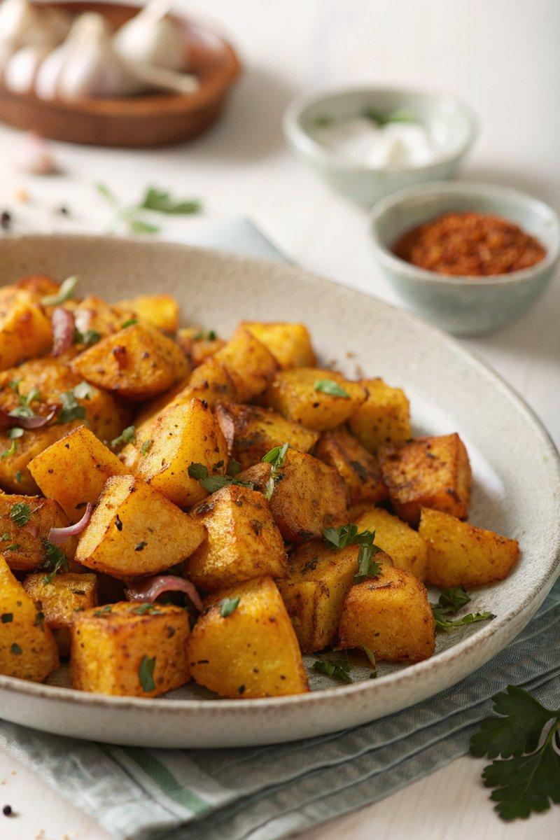

INGREDIENTS  - {'group': 'Main', 'item': '900g potatoes, unpeeled and diced into 2-3cm cubes'}  - {'group': 'Main', 'item': '2 tbsp cold-pressed rapeseed oil or olive oil'}  - {'group': 'Seasoning', 'item': '2 tsp ground turmeric'}  - {'group': 'Seasoning', 'item': '1 tsp fennel seeds'}  - {'group': 'Seasoning', 'item': '1 tsp cumin seeds'}  - {'group': 'Seasoning', 'item': '1 tsp nigella seeds'}  - {'group': 'Seasoning', 'item': '1 tsp black mustard seeds'}  - {'group': 'Seasoning', 'item': '1/2 tsp hot chilli powder'}  - {'group': 'Main', 'item': '1 bulb garlic, cloves separated but unpeeled'}  - {'group': 'Garnish', 'item': '1/2 red onion, finely diced'}  - {'group': 'Garnish', 'item': 'juice of 1 lime'}  - {'group': 'Seasoning', 'item': 'sea salt flakes, to taste'} | PREP  Preheat the oven to 200°C (400°F (200°C)). Dice the unpeeled potatoes into 2-3cm (1-inch) cubes. Finely dice the red onion and cover with lime juice to macerate while cooking.  COOK  Place the potato cubes in a freezer bag with rapeseed oil, turmeric, fennel seeds, cumin seeds, nigella seeds, mustard seeds, and chilli powder. Seal the bag and shake to coat the potatoes evenly. Spread the potatoes on a wide, shallow baking sheet, ensuring they are in a single layer. Scatter the unpeeled garlic cloves around the potatoes. Roast in the oven for 1 hour without turning.  PLATING  Transfer the roasted potatoes to a warmed serving dish. Sprinkle with sea salt flakes. Drain the macerated onion from the lime juice and scatter over the potatoes before serving.

NOTES:
These potatoes pair well with roasted chicken or can be served as a brunch dish alongside fried eggs.

