PAN-FRIED HALLOUMI WITH BEETROOT AND LIME  COOK TIME: 10 mins  SOURCE: Unknown  #halloumi #Mediterranean #pan-fry | 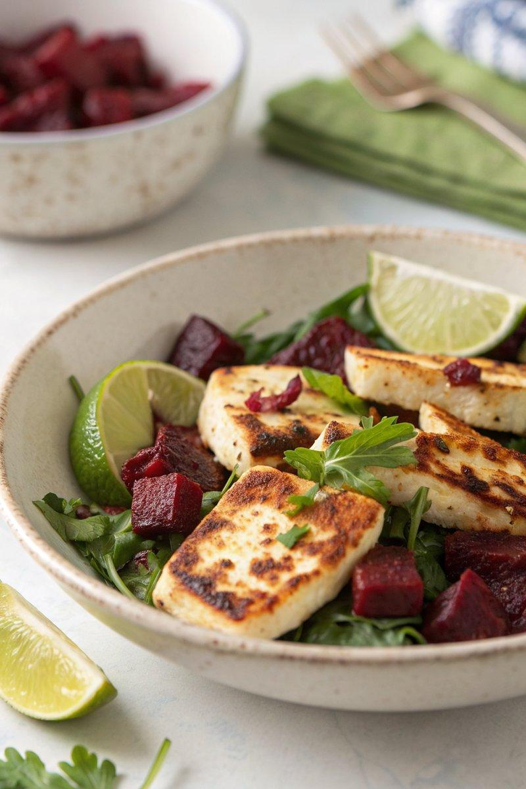

INGREDIENTS  - {'group': 'Main', 'item': '225-250g halloumi, sliced'}  - {'group': 'Main', 'item': '150g cooked beetroot, roughly chopped'}  - {'group': 'Sauce', 'item': '2 tsp lime juice'}  - {'group': 'Sauce', 'item': '30ml olive oil'} | PREP  Slice the halloumi into 8 pieces. Roughly chop the beetroot and blend with lime juice and olive oil until smooth.  COOK  Heat a large non-stick frying pan over high heat. Add the halloumi slices and cook for about 1 minute on each side until golden brown with scorch marks.  PLATING  Place the cooked halloumi on plates. Spoon the beetroot purée alongside the halloumi. Serve with warm pita bread and a peppery salad.

NOTES:
The beetroot purée can be prepared a day in advance and stored in the refrigerator.

