PEPPER, ANCHOVY, AND EGG SALAD  COOK TIME: 10 mins  SOURCE: Unknown  #egg #Mediterranean #no-cook | 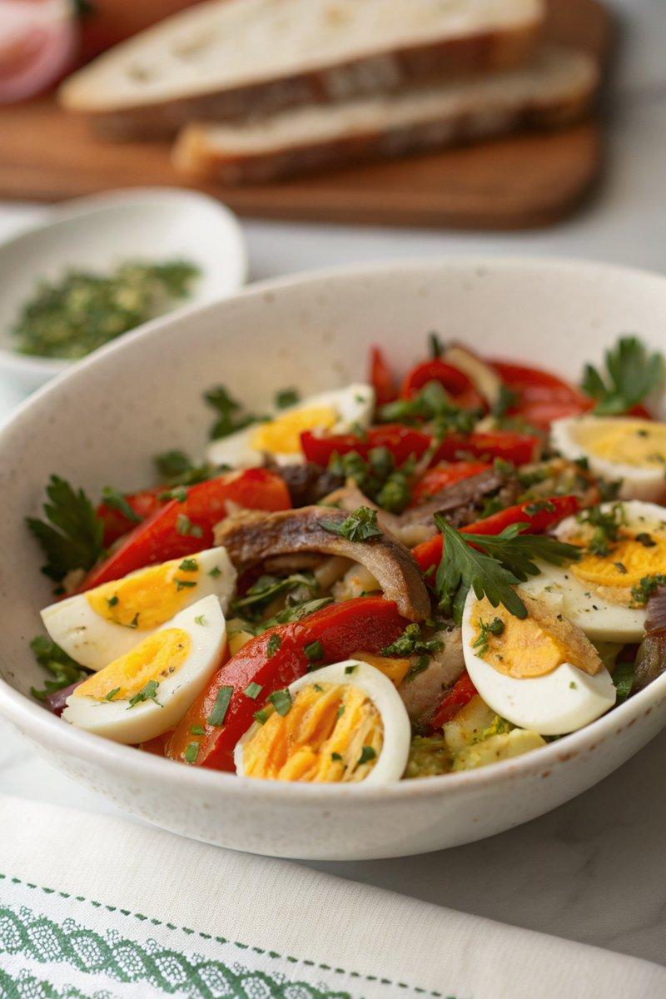

INGREDIENTS  - {'group': 'Main', 'item': '4 eggs'}  - {'group': 'Main', 'item': '580g chargrilled red peppers, drained'}  - {'group': 'Seasoning', 'item': '1 garlic clove, peeled'}  - {'group': 'Seasoning', 'item': 'Salt and pepper, to taste'}  - {'group': 'Garnish', 'item': '2 tbsp chopped fresh parsley'}  - {'group': 'Garnish', 'item': '1 tbsp drained capers'}  - {'group': 'Garnish', 'item': '12 anchovy fillets'}  - {'group': 'Dressing', 'item': '60ml olive oil'} | PREP  Peel the garlic clove and chop the parsley. Drain the chargrilled red peppers and cut them into strips. Drain the capers and anchovies.  COOK  Place the eggs in a saucepan and cover with water. Bring to a boil, then turn off the heat and let them sit for 10 mins. Refresh with cold water and peel.  PLATING  Arrange the pepper strips on a serving platter. Quarter the eggs and place them alongside the peppers. Scatter the capers and anchovies over the top. In a small bowl, mash the garlic with salt to form a paste, then mix with olive oil and parsley. Drizzle this dressing over the salad and serve immediately.

NOTES:
No additional notes

