CLASSIC COCOA BROWNIES  COOK TIME: 25 mins  SOURCE: Unknown  #chocolate #baking #dessert | 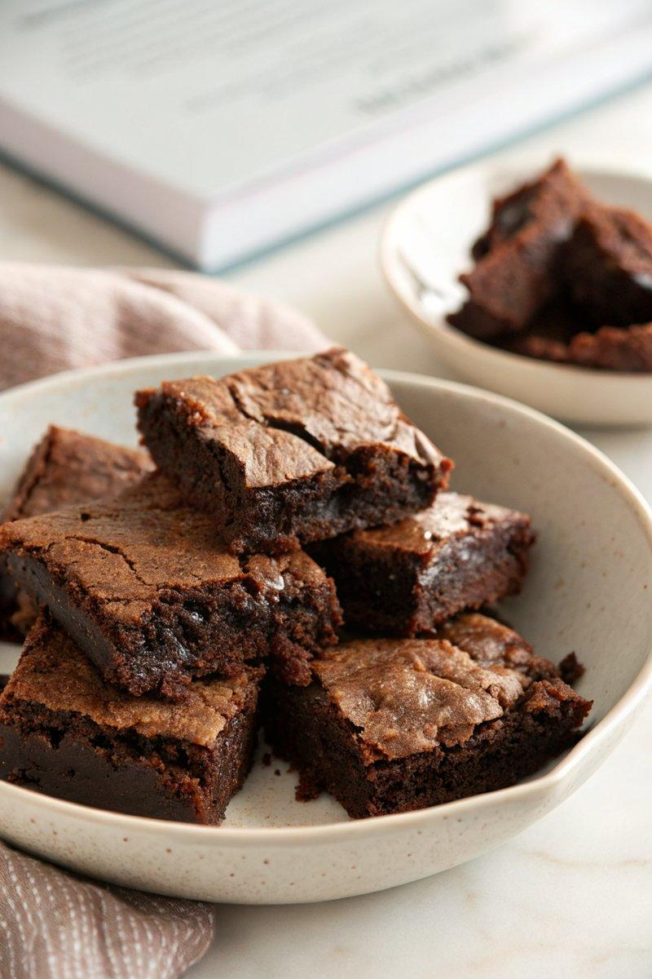

INGREDIENTS  - {'group': 'Main', 'item': '150g unsalted butter'}  - {'group': 'Main', 'item': '300g light brown muscovado sugar'}  - {'group': 'Main', 'item': '75g cocoa powder, sifted'}  - {'group': 'Main', 'item': '150g plain flour'}  - {'group': 'Main', 'item': '1 tsp bicarbonate of soda'}  - {'group': 'Main', 'item': 'pinch of salt'}  - {'group': 'Main', 'item': '2 large eggs'}  - {'group': 'Main', 'item': '1 tsp vanilla extract'}  - {'group': 'Main', 'item': '150g milk chocolate, chopped into small chunks'}  - {'group': 'Garnish', 'item': 'icing sugar, to dust (optional)'} | PREP  Preheat the oven to 190°C (375°F (190°C)). Line a 25cm (10-inch) square baking tin with foil.  COOK  Melt the butter over low heat in a medium saucepan. Stir in the sugar until well combined. Remove from heat and mix in the sifted cocoa powder, flour, bicarbonate of soda, and salt until a dry mixture forms. In a separate jug, whisk the eggs with vanilla extract, then incorporate into the dry mixture. Fold in the chopped milk chocolate. Pour the batter into the prepared tin, spreading evenly.  PLATING  Bake for 20-25 minutes until the top is set but the centre remains slightly wobbly. Cool on a rack before cutting into 16 squares. Dust with icing sugar if desired.

NOTES:
These brownies can be stored in an airtight container for up to 5 days. They are delicious both warm and cold.

