BUTTERY CREAM CHEESE CUPCAKE FROSTING  COOK TIME: N/A  SOURCE: Unknown  #frosting #dessert #no-cook | 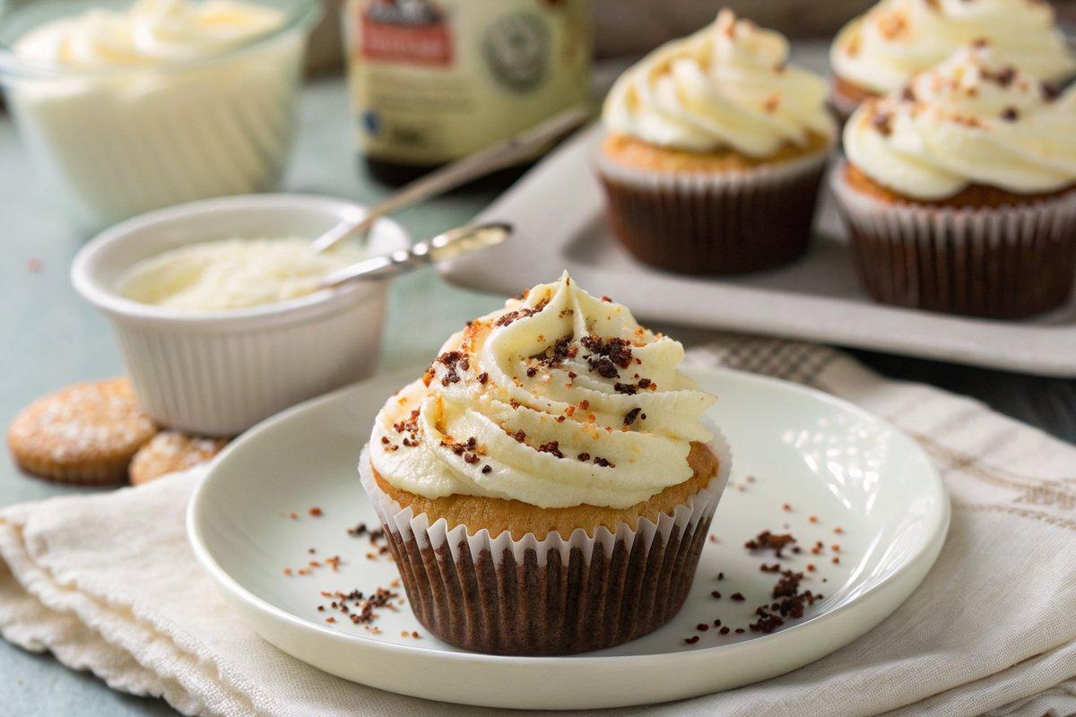

INGREDIENTS  - {'group': 'Icing', 'item': '500g icing sugar'}  - {'group': 'Icing', 'item': '125g cream cheese'}  - {'group': 'Icing', 'item': '125g soft unsalted butter'}  - {'group': 'Icing', 'item': '1 tsp cider vinegar or lemon juice'}  - {'group': 'Decoration', 'item': 'chocolate sprinkles, optional'}  - {'group': 'Decoration', 'item': 'red sugar, optional'} | PREP  Gather all ingredients. Ensure the cream cheese and butter are at room temperature for easy mixing.  COOK  In a food processor, combine the icing sugar, cream cheese, and butter. Process until smooth. Add the cider vinegar or lemon juice and blend again until the mixture is creamy and lump-free.  PLATING  Using a teaspoon or small spatula, spread the frosting evenly over each cupcake. Decorate with chocolate sprinkles and red sugar as desired.

NOTES:
The frosting can be prepared a day in advance. Store covered in the refrigerator and bring to room temperature before using. Un-iced cupcakes can be stored in airtight containers for up to 2 days or frozen for up to 2 months.

