CLASSIC CHOCOLATE CHIP COOKIES  COOK TIME: 15-17 mins  SOURCE: Unknown  #cookies #American #bake | 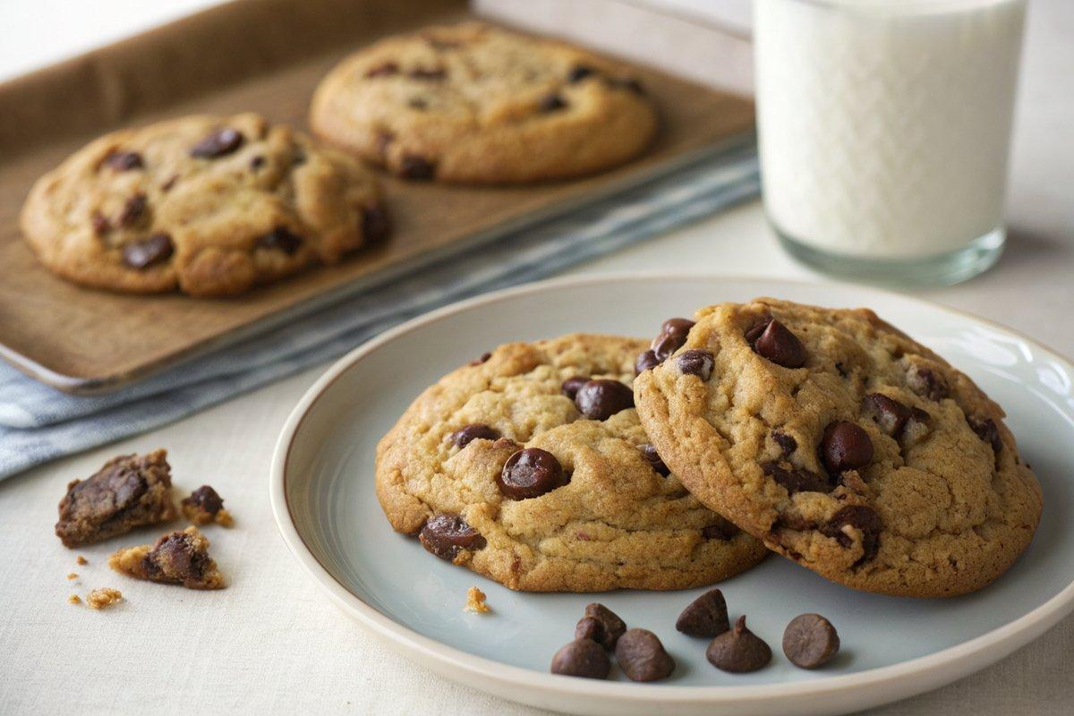

INGREDIENTS  - {'group': 'Main', 'item': '150g soft unsalted butter'}  - {'group': 'Main', 'item': '125g soft light brown sugar'}  - {'group': 'Main', 'item': '100g caster sugar'}  - {'group': 'Main', 'item': '2 tsp vanilla extract'}  - {'group': 'Main', 'item': '1 egg, fridge-cold'}  - {'group': 'Main', 'item': '1 egg yolk, fridge-cold'}  - {'group': 'Main', 'item': '300g flour'}  - {'group': 'Main', 'item': '1 tsp bicarbonate of soda'}  - {'group': 'Main', 'item': '326g milk chocolate chips'} | PREP  Preheat the oven to 170°C (340°F (171°C)). Line a large baking sheet with baking parchment. Melt the butter and allow it to cool slightly. In a bowl, combine the brown sugar and caster sugar, then pour the cooled melted butter over them and mix until well combined. Beat in the vanilla extract, cold egg, and cold egg yolk until the mixture is light and creamy.  COOK  Gradually mix in the flour and bicarbonate of soda until just blended. Fold in the chocolate chips. Using a 60ml ice cream scoop or a quarter-cup measure, scoop the dough onto the prepared baking sheet, spacing them about 5cm apart. Bake in the preheated oven for 15-17 minutes, or until the edges are lightly golden.  PLATING  Allow the cookies to cool on the baking sheet for 5 minutes before transferring them to a wire rack to cool completely.

NOTES:
Store cookies in an airtight container for up to 1 month. The dough can be frozen for 2-3 months; bake from frozen, adding a few extra minutes to the baking time.

