BAKED EGG CUSTARD  COOK TIME: 1 hr  SOURCE: Unknown  #egg #British #bake | 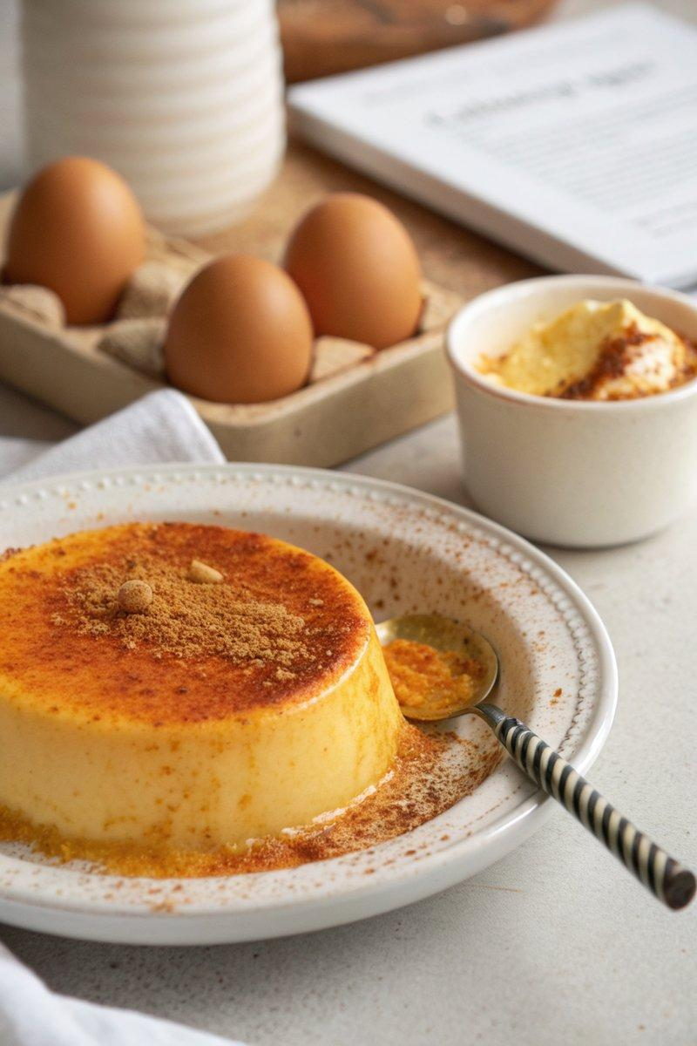

INGREDIENTS  - {'group': 'Main', 'item': '568ml full-fat milk'}  - {'group': 'Main', 'item': '4 eggs'}  - {'group': 'Main', 'item': '50g caster sugar'}  - {'group': 'Main', 'item': '2 tsp vanilla extract'}  - {'group': 'Main', 'item': 'fresh nutmeg, for grating'}  - {'group': 'Main', 'item': 'butter, for greasing'} | PREP  Preheat the oven to 140°C (285°F (141°C)). Grease a round ovenproof dish (~17cm (7-inch) diameter) with butter. In a large bowl, whisk together the eggs, caster sugar, and vanilla extract until well combined.  COOK  Heat the full-fat milk in a saucepan until hot but not boiling. Gradually whisk the hot milk into the egg mixture. Strain this custard mixture through a sieve into the prepared dish. Place the dish in a roasting tin and pour boiling water into the tin until it reaches halfway up the sides of the dish. Carefully transfer to the oven and bake for 1 hour, or until the custard is set but still slightly wobbly in the center.  PLATING  Remove the dish from the water bath and let the custard cool slightly before serving. Grate fresh nutmeg over the top before serving warm. Alternatively, allow it to cool completely for a chilled dessert.

NOTES:
For best results, do not refrigerate the custard as it may alter the texture. Serve with fresh raspberries for added flavour.

