COFFEE TOFFEE MERINGUES  COOK TIME: 45 mins  SOURCE: Unknown  #meringue #French #bake | 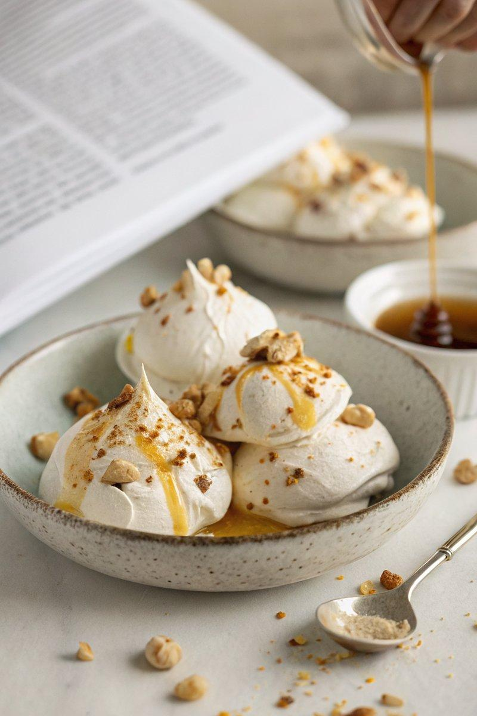

INGREDIENTS  - {'group': 'Meringues', 'item': '200g caster sugar'}  - {'group': 'Meringues', 'item': '50g soft light brown sugar'}  - {'group': 'Meringues', 'item': '2 tsp instant espresso powder'}  - {'group': 'Meringues', 'item': 'pinch cream of tartar'}  - {'group': 'Meringues', 'item': '4 egg whites'}  - {'group': 'Meringues', 'item': '100g toasted chopped hazelnuts (optional)'}  - {'group': 'Toffee Sauce', 'item': '15g butter'}  - {'group': 'Toffee Sauce', 'item': '75g golden syrup'}  - {'group': 'Toffee Sauce', 'item': '25g soft light brown sugar'}  - {'group': 'Toffee Sauce', 'item': '60ml double cream'}  - {'group': 'Toffee Sauce', 'item': '2 tsp Frangelico hazelnut liqueur (optional)'}  - {'group': 'Filling', 'item': '600ml double cream'} | PREP  Preheat the oven to 140°C (285°F (141°C)). In a bowl, mix caster sugar, brown sugar, espresso powder, and cream of tartar. Set aside. Prepare a baking sheet with parchment paper.  COOK  Whisk egg whites in a clean bowl until soft peaks form. Gradually add the sugar mixture, one tablespoon at a time, whisking until the meringue is glossy and thick. Spoon meringue onto the baking sheet in 8-10 rounds, about 10cm in diameter. Optionally, sprinkle with hazelnuts. Bake for 45 mins until the meringues are dry outside but soft inside. For the sauce, melt butter, golden syrup, and brown sugar in a pan over low heat. Bring to a boil and simmer for 2 mins. Remove from heat, whisk in cream and liqueur, and set aside.  PLATING  Whip the double cream until firm. Gently crush the tops of the meringues and fill with whipped cream. Drizzle with toffee sauce and sprinkle with remaining hazelnuts if desired.

NOTES:
These meringues are best served fresh. The toffee sauce can be made ahead and stored in the fridge.

