VENETIAN CARROT CAKE  COOK TIME: 30-40 mins  SOURCE: Unknown  #carrot #Italian #bake | 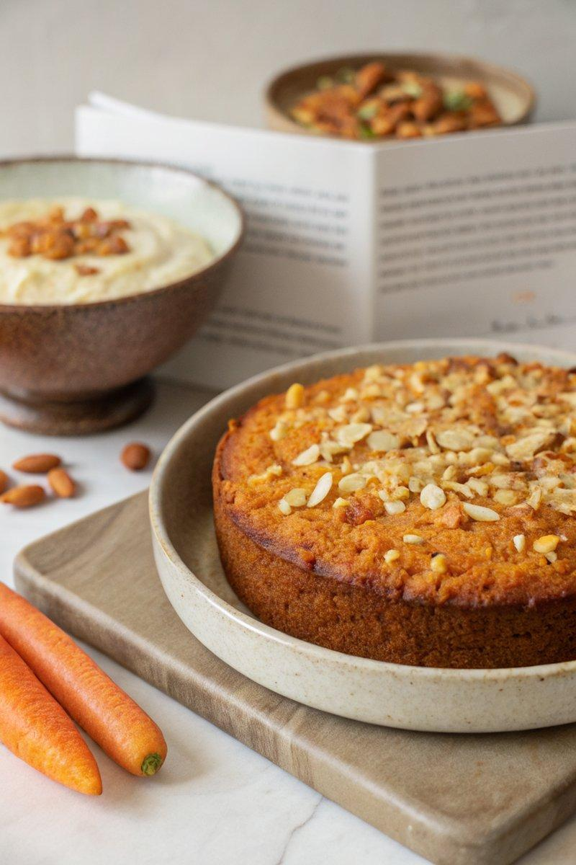

INGREDIENTS  - {'group': 'Main', 'item': '2 medium carrots (200-250g), grated'}  - {'group': 'Main', 'item': '75g golden sultanas'}  - {'group': 'Main', 'item': '60ml rum'}  - {'group': 'Main', 'item': '150g caster sugar'}  - {'group': 'Main', 'item': '125ml olive oil, plus extra for greasing'}  - {'group': 'Main', 'item': '1 tsp vanilla extract'}  - {'group': 'Main', 'item': '3 eggs'}  - {'group': 'Main', 'item': '250g ground almonds'}  - {'group': 'Main', 'item': '1 tsp nutmeg'}  - {'group': 'Main', 'item': 'Zest and juice of 1 lemon'}  - {'group': 'Main', 'item': '3 tbsp toasted pine nuts'}  - {'group': 'Mascarpone Cream (optional)', 'item': '250g mascarpone'}  - {'group': 'Mascarpone Cream (optional)', 'item': '2 tsp icing sugar'}  - {'group': 'Mascarpone Cream (optional)', 'item': '30ml rum'} | PREP  Preheat the oven to 180°C (350°F (175°C)). Line a 23cm (9-inch) springform pan with baking parchment and grease the sides with olive oil. Grate the carrots and place them on a double layer of kitchen roll to absorb excess moisture. In a small saucepan, combine the golden sultanas and rum, bring to a boil, then simmer for 3 minutes. Toast the pine nuts in a pan until golden.  COOK  In a large bowl, whisk together the caster sugar and olive oil until creamy. Add the vanilla extract and eggs, whisking until well combined. Fold in the ground almonds, nutmeg, grated carrots, sultanas with any remaining rum, and lemon zest and juice. Pour the batter into the prepared pan, smoothing the surface. Sprinkle with toasted pine nuts. Bake for 30-40 minutes, or until the cake is golden and a tester comes out mostly clean.  PLATING  Allow the cake to cool in the pan for 10 minutes, then transfer to a wire rack to cool completely. For the optional mascarpone cream, mix mascarpone with icing sugar and rum, and serve alongside the cake.

NOTES:
This cake can be made up to 3 days in advance. Wrap tightly and store in an airtight container. Serve with or without the mascarpone cream.

