SPICED PUMPKIN CHUTNEY  COOK TIME: 1 hr  SOURCE: Unknown  #pumpkin #Indian #simmer | 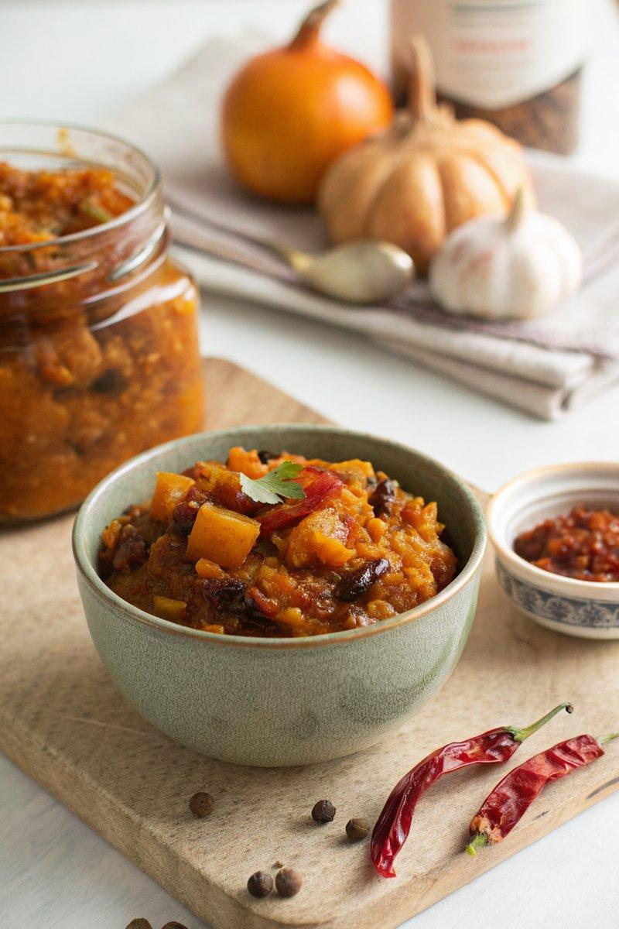

INGREDIENTS  - {'group': 'Main', 'item': '1.29kg pumpkin, yielding ~1kg once peeled and de-seeded'}  - {'group': 'Main', 'item': '2 medium onions, finely chopped'}  - {'group': 'Main', 'item': '1 Bramley cooking apple, cored and chopped'}  - {'group': 'Main', 'item': '100g golden sultanas'}  - {'group': 'Main', 'item': "2 red bird's-eye chillies, de-seeded and chopped"}  - {'group': 'Seasoning', 'item': '275g soft light brown sugar'}  - {'group': 'Seasoning', 'item': '1 tsp ground cinnamon'}  - {'group': 'Seasoning', 'item': '1 tsp ground ginger'}  - {'group': 'Seasoning', 'item': '1 tsp ground cloves'}  - {'group': 'Seasoning', 'item': '2 tsp sea salt flakes or 1 tsp pouring salt'}  - {'group': 'Seasoning', 'item': '2 heaped tbsp minced fresh ginger'}  - {'group': 'Main', 'item': '625ml white wine vinegar'} | PREP  Peel and de-seed the pumpkin, then dice it into small cubes. Finely chop the onions and apple. De-seed and chop the chillies.  COOK  In a large saucepan, combine the pumpkin, onions, apple, sultanas, chillies, brown sugar, cinnamon, ground ginger, cloves, salt, fresh ginger, and vinegar. Bring the mixture to a boil, stirring to dissolve the sugar. Reduce the heat to medium and simmer for about 1 hour, or until the chutney thickens and the pumpkin is tender. Check after 45 minutes and cover loosely if needed to prevent drying out.  PLATING  Spoon the hot chutney into sterilized jars, seal with vinegar-proof lids, and allow to cool. Store in a cool, dark place for at least 2 months before using to allow the flavours to develop.

NOTES:
This chutney is ideal for preserving and can be made with butternut squash if pumpkin is unavailable. Ensure jars are properly sterilized to prevent spoilage.

