GINGERBREAD WITH GUINNESS  COOK TIME: 45 mins  SOURCE: Unknown  #gingerbread #British #bake | 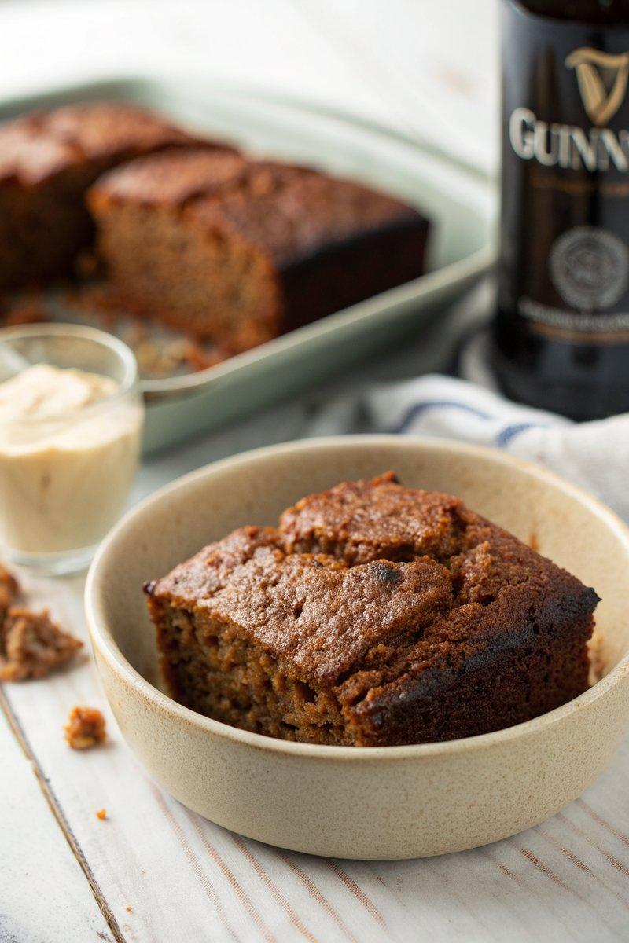

INGREDIENTS  - {'group': 'Main', 'item': '150g butter, plus extra for greasing'}  - {'group': 'Main', 'item': '300g golden syrup'}  - {'group': 'Main', 'item': '200g dark muscovado sugar'}  - {'group': 'Main', 'item': '250ml Guinness'}  - {'group': 'Main', 'item': '2 tsp ground ginger'}  - {'group': 'Main', 'item': '2 tsp ground cinnamon'}  - {'group': 'Main', 'item': '1/4 tsp ground cloves'}  - {'group': 'Main', 'item': '300g plain flour'}  - {'group': 'Main', 'item': '2 tsp bicarbonate of soda'}  - {'group': 'Main', 'item': '300ml sour cream'}  - {'group': 'Main', 'item': '2 eggs'} | PREP  Preheat the oven to 170°C (340°F (171°C)). Line a 23cm (9-inch) square baking tin with foil and grease it lightly.  COOK  In a saucepan, melt the butter, golden syrup, dark muscovado sugar, and Guinness over low heat. Stir in the ground ginger, cinnamon, and cloves. Remove from heat and whisk in the flour and bicarbonate of soda until smooth. In a separate bowl, whisk together the sour cream and eggs, then incorporate into the gingerbread mixture, ensuring a lump-free batter. Pour the batter into the prepared tin and bake for about 45 minutes, until the centre is risen and the edges pull away from the sides.  PLATING  Allow the gingerbread to cool in the tin before cutting into squares or slices for serving.

NOTES:
This gingerbread pairs well with fresh fruit like diced mango or sour plums for a delightful contrast.

