CHOCOLATE ORANGE LOAF CAKE  COOK TIME: 45 mins  SOURCE: Unknown  #chocolate #baking #cake | 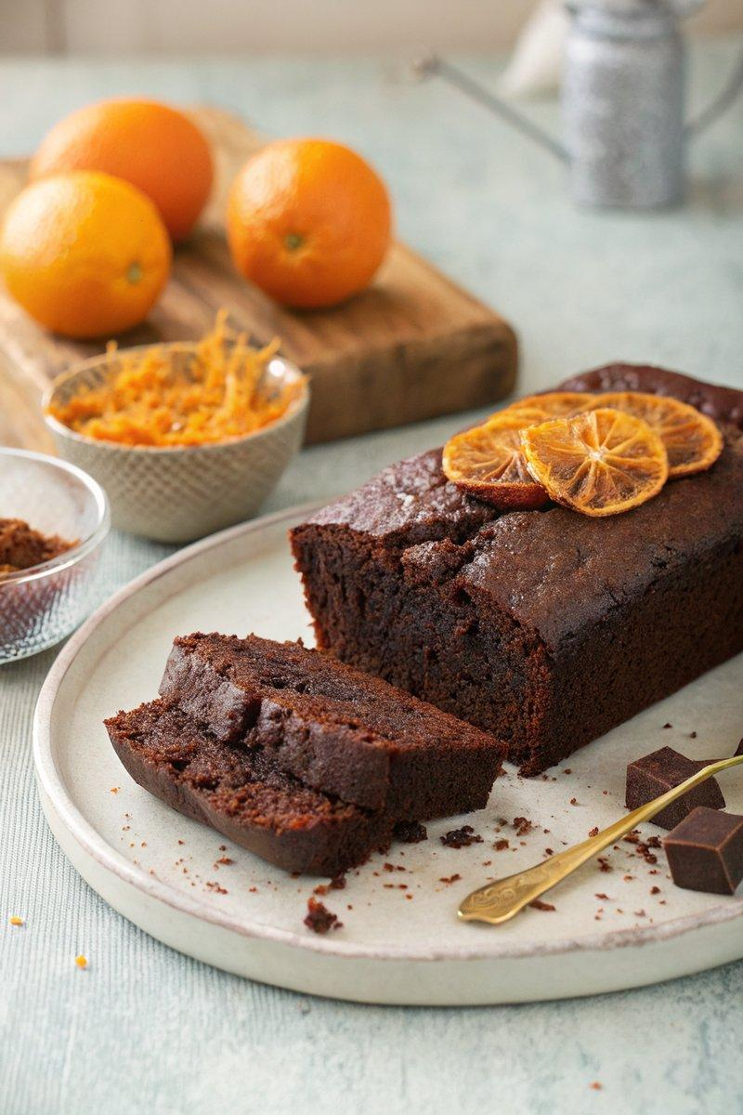

INGREDIENTS  - {'group': 'Main', 'item': '150g soft unsalted butter'}  - {'group': 'Main', 'item': '2 tbsp golden syrup'}  - {'group': 'Main', 'item': '175g dark muscovado sugar'}  - {'group': 'Main', 'item': '150g plain flour'}  - {'group': 'Main', 'item': '1 tsp bicarbonate of soda'}  - {'group': 'Main', 'item': '25g best-quality cocoa powder'}  - {'group': 'Main', 'item': '2 eggs'}  - {'group': 'Main', 'item': 'Zest of 2 oranges'}  - {'group': 'Main', 'item': 'Juice of 2 oranges'} | PREP  Preheat the oven to 170°C (340°F (171°C)) and line a 900g loaf tin with baking parchment. Grate the zest and juice the oranges, setting them aside.  COOK  In a large bowl, beat the softened butter with the golden syrup until smooth. Gradually add the dark muscovado sugar, mixing until well combined. In a separate bowl, sift together the flour, bicarbonate of soda, and cocoa powder. Add a spoonful of the dry mixture to the butter mixture, then beat in one egg. Repeat with the remaining dry ingredients and the second egg. Stir in the orange zest and juice, mixing until the batter is smooth. Pour the batter into the prepared loaf tin and bake for 45 mins, checking for doneness with a cake tester.  PLATING  Allow the cake to cool in the tin for a few minutes before transferring it to a wire rack to cool completely. Slice into 10-12 pieces and serve.

NOTES:
The cake is meant to be slightly gooey in the center, so a cake tester may not come out completely clean. Store wrapped in foil to maintain moisture.

