SWEET AND SALTY CHOCOLATE NUT BARS  COOK TIME: 4 hrs (chilling time)  SOURCE: Unknown  #chocolate #dessert #no-cook | 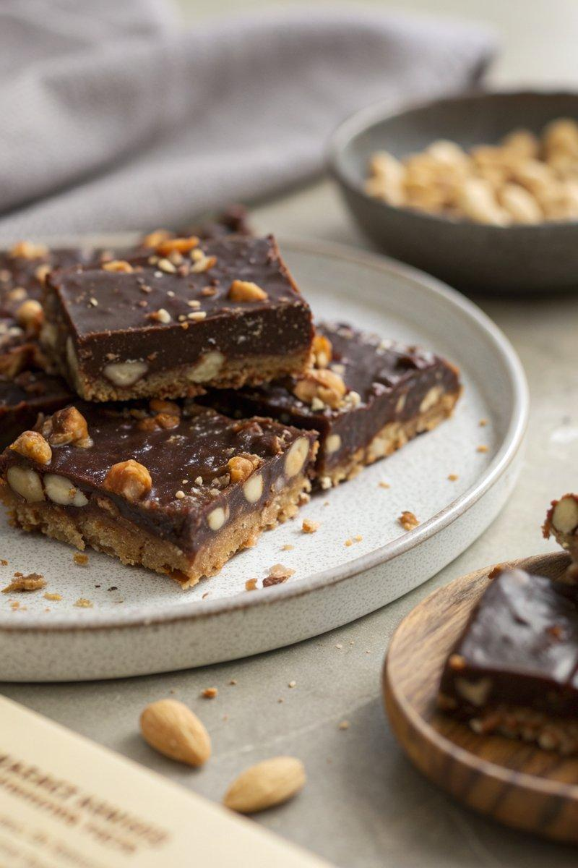

INGREDIENTS  - {'group': 'Main', 'item': '200g dark chocolate'}  - {'group': 'Main', 'item': '100g milk chocolate'}  - {'group': 'Main', 'item': '125g unsalted butter'}  - {'group': 'Main', 'item': '150ml golden syrup'}  - {'group': 'Main', 'item': '250g salted peanuts'}  - {'group': 'Main', 'item': '4 x 40g Crunchie bars'} | PREP  Line a 25cm springform tin or a 30 x 20 x 5cm foil tray with foil. Break the dark and milk chocolate into pieces.  COOK  In a heavy-based saucepan, melt the chocolate pieces with the unsalted butter and golden syrup over low heat, stirring until smooth. In a separate bowl, crush the Crunchie bars into small pieces. Remove the chocolate mixture from heat and stir in the salted peanuts and crushed Crunchie bars until well combined.  PLATING  Pour the mixture into the prepared tin or tray, smoothing the top with a spatula. Refrigerate for about 4 hours until set. Once firm, cut into desired sizes and serve.

NOTES:
These bars can be made a day in advance and stored in an airtight container for several days.

