SAFFRON RISOTTO WITH MARSALA  COOK TIME: 20 mins  SOURCE: Unknown  #risotto #Italian #sauté | 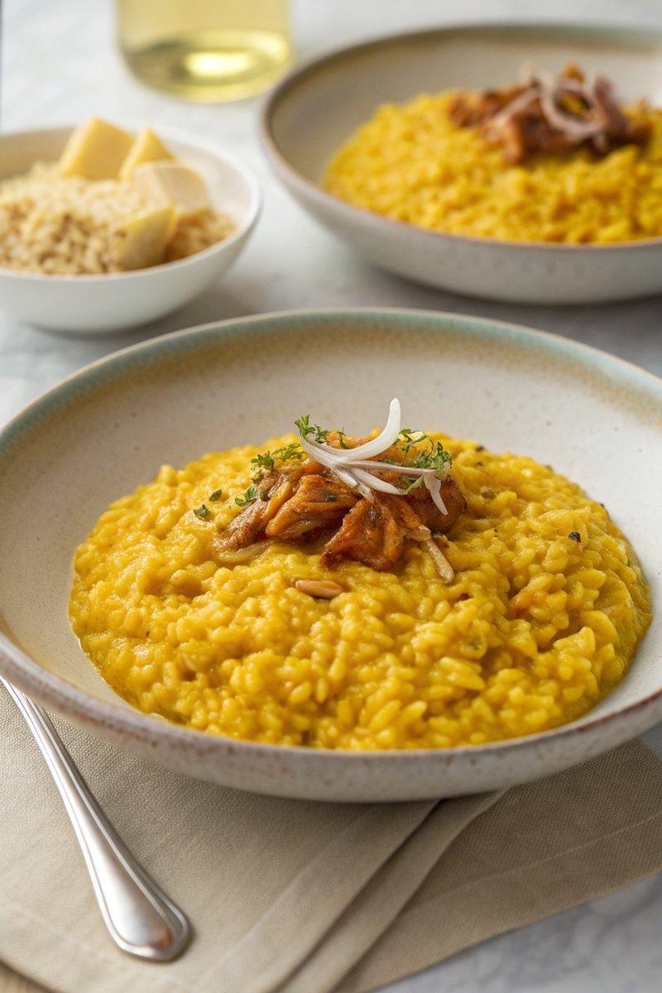

INGREDIENTS  - {'group': 'Main', 'item': '250g risotto rice'}  - {'group': 'Main', 'item': '1L chicken or vegetable stock'}  - {'group': 'Main', 'item': '50g butter, plus 15g extra'}  - {'group': 'Main', 'item': '1 tbsp olive oil'}  - {'group': 'Main', 'item': '50g shallots, finely chopped'}  - {'group': 'Main', 'item': '125ml dry Marsala wine'}  - {'group': 'Main', 'item': '0.4g saffron threads'}  - {'group': 'Main', 'item': '25g grated Parmesan cheese, plus extra to serve'}  - {'group': 'Seasoning', 'item': 'Salt and pepper, to taste'} | PREP  Finely chop the shallots. Measure out the saffron threads and Marsala wine. Grate the Parmesan cheese.  COOK  Heat the stock in a saucepan and add the saffron threads, keeping it warm over low heat. In a separate wide, shallow saucepan, melt 50g of butter with the olive oil over medium heat. Add the chopped shallots and sauté until softened. Stir in the risotto rice, cooking for about a minute. Increase the heat and pour in the Marsala wine, stirring until absorbed. Gradually add the saffron-infused stock, one ladle at a time, allowing each to be absorbed before adding the next. Continue stirring until the rice is al dente, about 15 minutes.  PLATING  Remove from heat and stir in the remaining butter and Parmesan cheese. Season with salt and pepper to taste. Serve immediately in warmed bowls, garnished with extra Parmesan cheese.

NOTES:
For a richer flavour, consider adding bone marrow along with the butter at the beginning. Adjust the amount of stock based on the desired texture of the risotto.

